



## PUNJAB TIANJIN UNIVERSITY OF TECHNOLOGY

|  |  |
| --- | --- |
| Name | Muhammad Khubaib |
| Roll # | 23-SET-017 |
| Subject | WEB DEVELOPMENT |
| Semester | **Spring2025 (4th Semester)** |

**LAB MANUALS**

## Department: Software Engineering Technology



### LAB 01

**Introduction to HTML Web Development**

Create a simple website home page using HTML.

**File structure:**

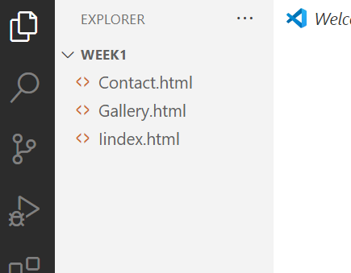

**Step1:Code of html of Index.html, Contact.html, Gallery.html.**

**Index.html:**

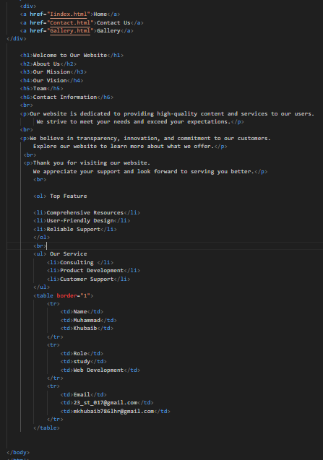

**Gallery.html:**

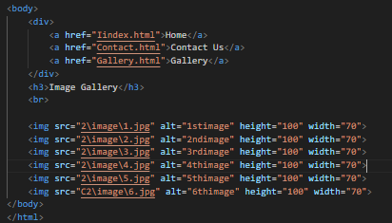

**Contact.html:**

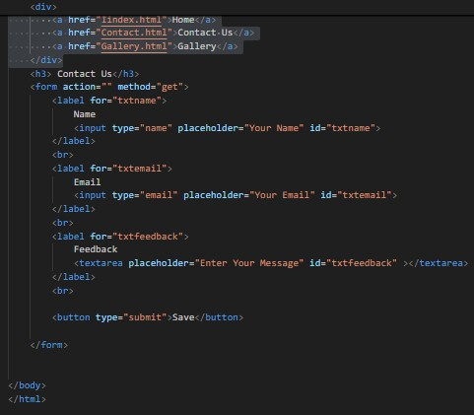

**Step2:Run on chrome Browser index.html, Contact.html, Gallery.html and Show it.**

**Index.html:**

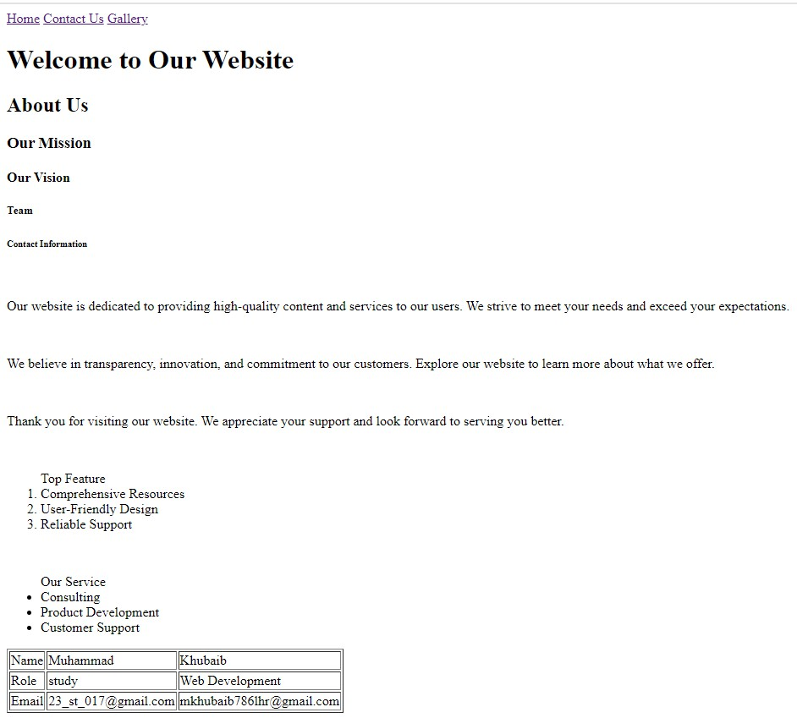

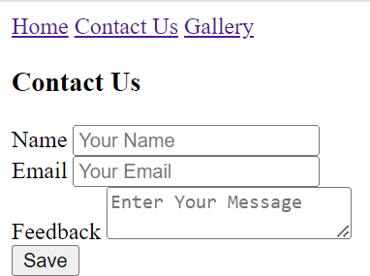**Contact.html:**

**Gallery.html**:

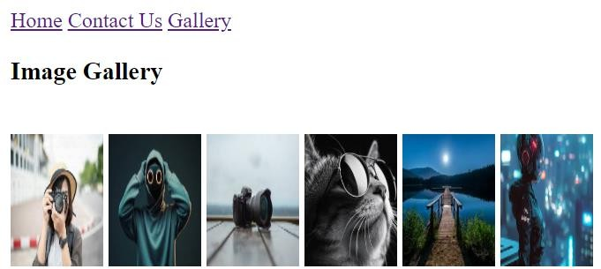



#### GENERALIZED LAB RUBRICS

|  |  |  |  |  |  |  |  |  |
| --- | --- | --- | --- | --- | --- | --- | --- | --- |
| **Domain** | **Component with Taxonomy** | **Above Expectation (4)** | **Meeting Expectation (3)** | **Approaching Expectation (2)** | **Below Expectation (1)** | **Used** | **Weight / 100**  **(Optional)** | **Score (1–4)** |
| **Psychomotor** | **Building (Hardware)** | **Is able to build a given setup neatly and timely using correct hardware components and**  **/ or can reorganize / adapt to new / special**  **requirements** | **Is able to assemble a given setup using correct hardware components after minor revisions** | **Is only able to copy a given setup using correct hardware components** | **Is not able to assemble a given setup using correct hardware components** | ☐ |  |  |
| **Cognitive** | **Recording Measurements (Hardware / Software)** | **Is able to record accurate measurements all the time** | **Is able to record accurate measurements most of the time** | **Is only able to record accurate measurements on some**  **occasions** | **Is unable to record accurate measurements** | ☐ |  |  |
| **Investigation (Software)** | **Is able to formulate**  **/develop theories in addition to evaluating**  **/concluding correctly about investigation parameters by**  **assessing data** | **Is able to evaluate**  **/conclude correctly about investigation parameters by assessing data** | **Is partially able to evaluate**  **/conclude correctly about investigation parameters by assessing data** | **Is unable to comprehend investigation parameters** | ☐ |  |  |
| **Design / Development of Solution (Hardware / Software)** | **Is able to design**  **/ develop the solution of a given problem and add features**  **to it** | **Is able to design**  **/ develop the solution of a given problem** | **Is able to partially design**  **/ develop the solution of a given problem** | **Is unable to partially design / develop the solution of a**  **given problem** | ☐ |  |  |
| **Software Usage (Software)** | **Is adept in the use of software tool and can access advanced features** | **Is able to use the software tool effectively by accessing all the required**  **features** | **Is able to use the software tool but cannot access all the required**  **features** | **Is unable to use the software tool** | ☐ |  |  |
| **Programming Language (Software)** | **Is able to efficiently complete a given task using advanced programming language constructs / methods / commands and/or add features to the**  **original task** | **Is able to complete a given task using required programming language constructs / methods / commands** | **Is able to partially complete a given task** | **Is unable to partially complete a given task** | ☐ |  |  |



**GENERALIZED LAB RUBRICS**

|  |  |  |  |  |  |  |  |  |
| --- | --- | --- | --- | --- | --- | --- | --- | --- |
| **Domain** | **Component with Taxonomy** | **Above Expectation (4)** | **Meeting Expectation (3)** | **Approaching Expectation (2)** | **Below Expectation (1)** | **Used** | **Weight / 100**  **(Optional)** | **Score (1–4)** |
| **Affective** | **Safety Instructions (PLO6)** | **Assesses and complies with all EHS instructions**  **while in lab** | **Assesses and complies with most EHS instructions**  **while in lab** | **Assesses and complies with some EHS instructions**  **while in lab** | **Assesses and complies with few EHS instructions in**  **lab** | ☐ |  |  |
| **Professional Ethics (PLO8)** | **Exhibits exemplary professional ethics while writing lab reports and dealing with fellow students, lab staff and instructor all the time** | **Exhibits professional ethics while writing lab reports and dealing with fellow students, lab staff and instructor all the time** | **Makes an effort to exhibit professional ethics while writing lab reports and dealing with fellow students, lab staff and instructor all the time** | **Does not exhibit professional ethics while writing lab reports and dealing with fellow students, lab staff and**  **instructor all the time** | ☐ |  |  |
| **Contribution (PLO9)** | **Consistently shows full preparation by completing all agreed tasks and provides additional resources for the group and**  **work quality is excellent** | **Consistently shows full preparation by completing all agreed tasks and work requires little or no revisions** | **Shows some preparation which is mostly at superficial level in completing a task and work requires much revisions and editing** | **Shows very little or no preparation in completing a task and work quality is poor** | ☐ |  |  |
| **Attitude (PLO9)** | **Internalized positive behavior and encourages and helps other team members** | **Consistent positive behavior most of the time towards other team members** | **Neither helpful nor damaging and shows disinterest in the performance of**  **others** | **Discouraging behavior towards other team members** | ☐ |  |  |
| **Report Writing (PLO10)** | **Report on all relevant sections related to the lab tasks is completed accurately, meeting the requirements, in prescribed time and with good language skills** | **Report on all relevant sections related to the lab tasks is completed but few deficiencies are present in terms of accuracy / meeting the requirements / prescribed time**  **/ good language skills** | **Report on all relevant sections related to the lab tasks is completed but many deficiencies are present in terms of accuracy / meeting the requirements / prescribed time**  **/ good language skills** | **Report on all relevant sections related to the lab tasks is not completed** | ☐ |  |  |
| **Lab Task Management (PLO11)** | **Manages tasks well within given timeframe** | **Manages tasks within given timeframe** | **Manages tasks in an extended timeframe** | **Does not manage tasks even in extended**  **timeframes** | ☐ |  |  |



### LAB 02

**Introduction To CSS Web Development**

Apply CSS styling to the HTML page created in the previous lab.

**File Structure:**

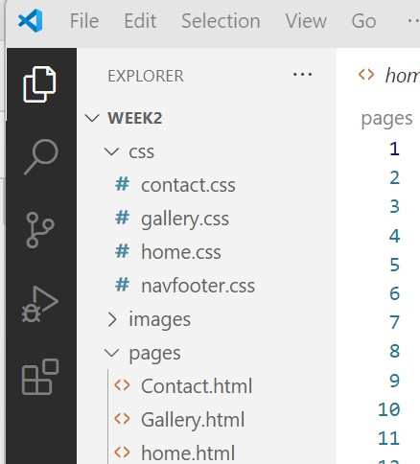

**Part1: Create previous lab1 file Home.css , Gallery.css , Contact.css and Navfotter.css.and apply styling to the html pages.**

**Home.css**

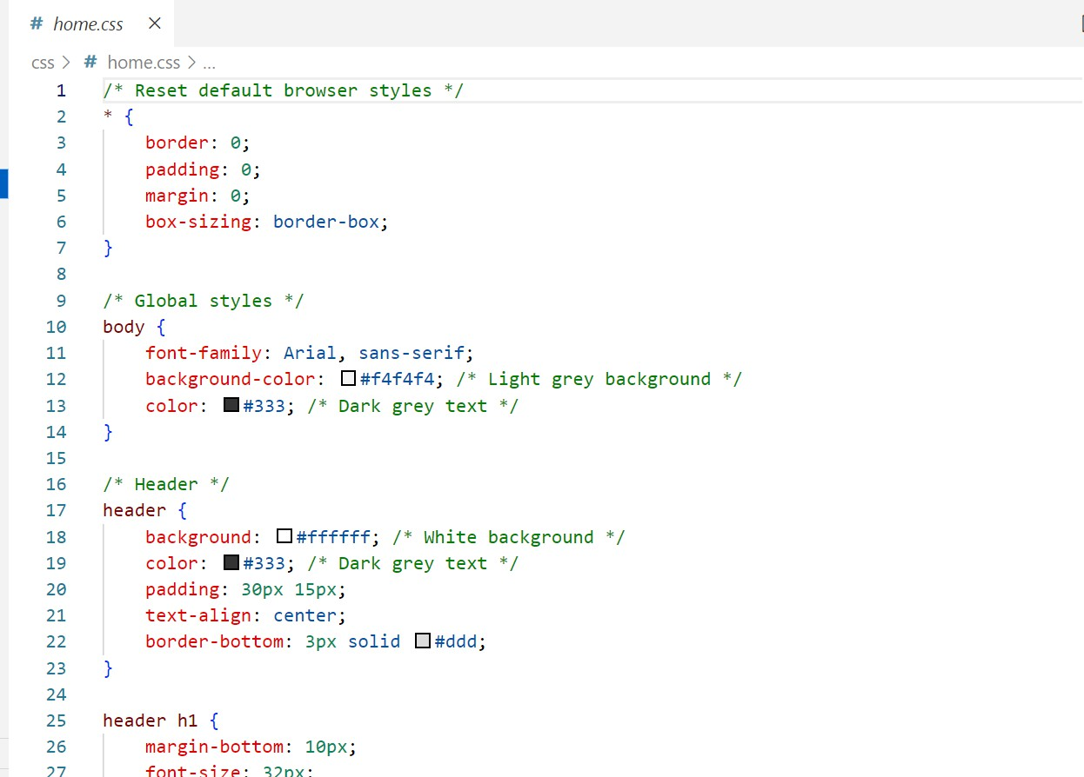

**Contact.css**

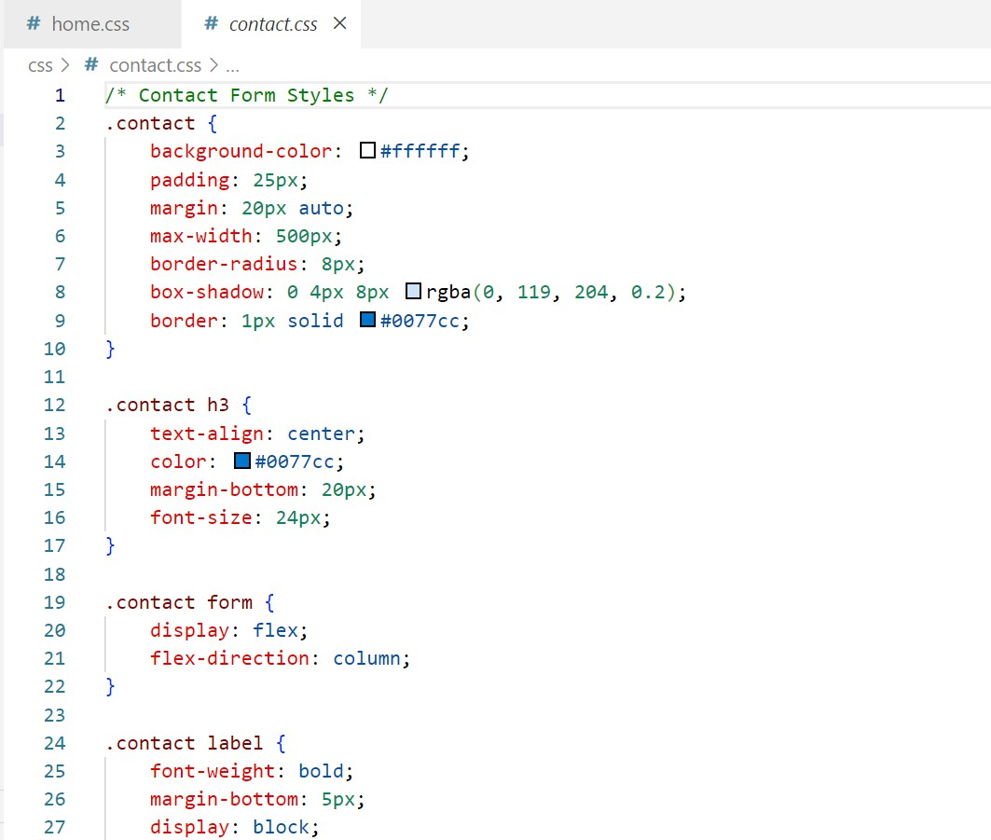

**Gallery.css**

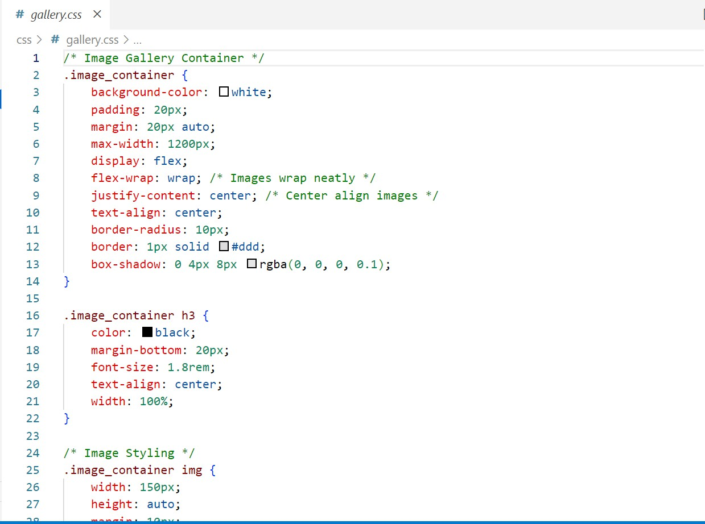

**Navfooter.css**

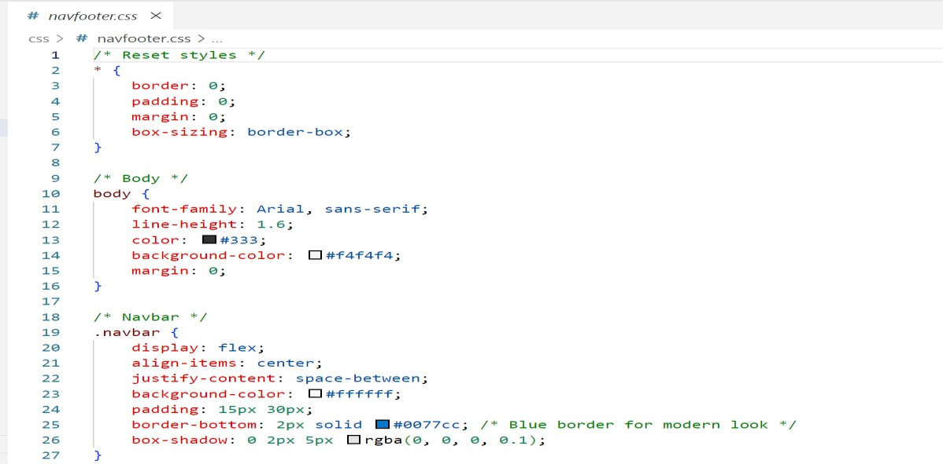

**Part2: Project run on browser and show it:**

**HomePage**

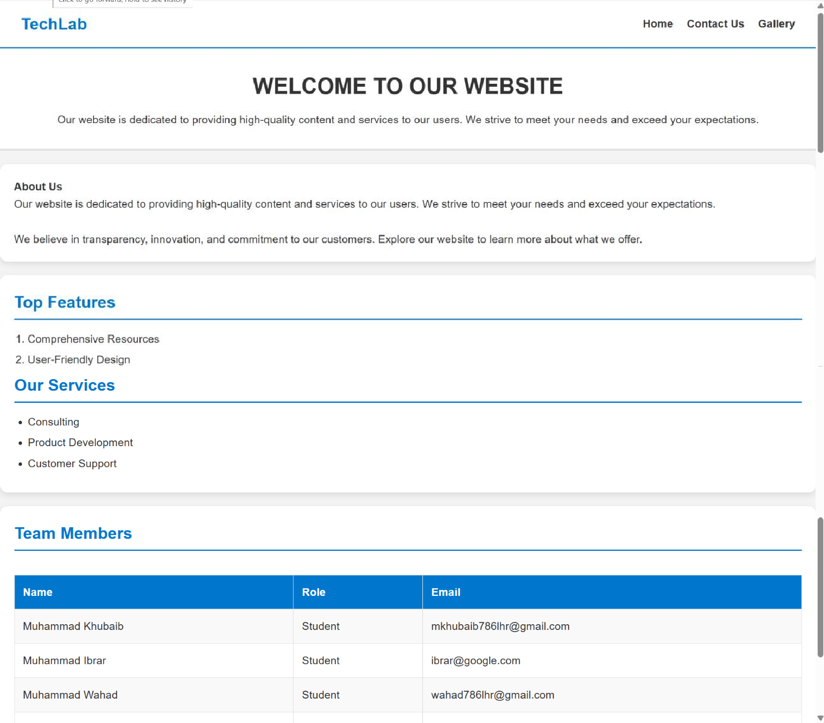

**GalleryPage**

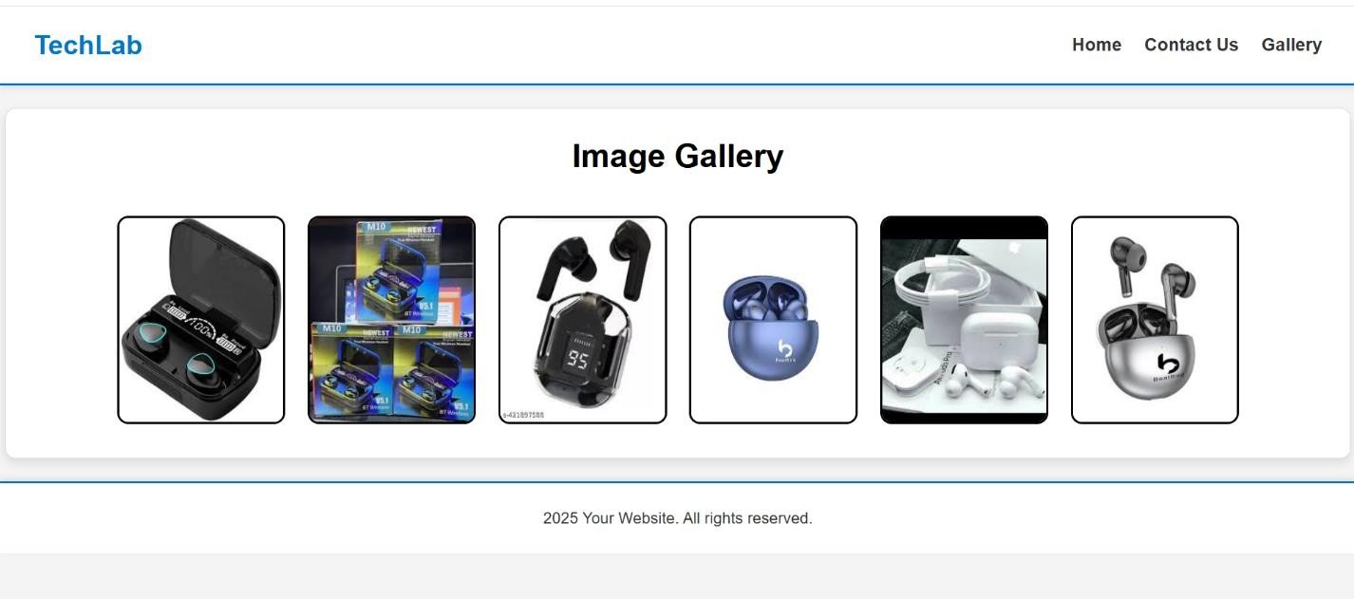

**ContactPage**

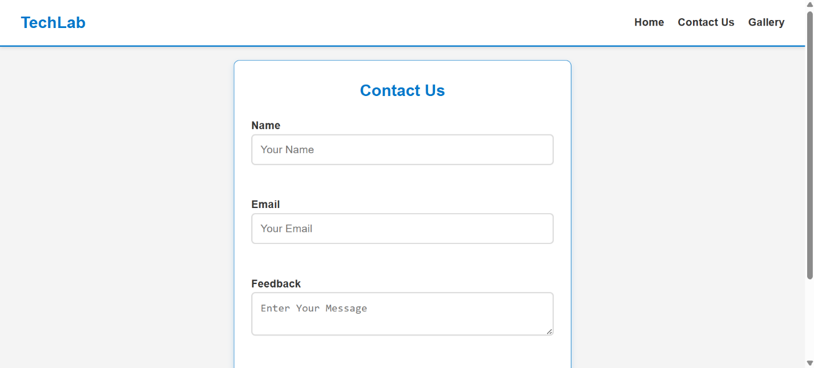



#### GENERALIZED LAB RUBRICS

|  |  |  |  |  |  |  |  |  |
| --- | --- | --- | --- | --- | --- | --- | --- | --- |
| **Domain** | **Component with Taxonomy** | **Above Expectation (4)** | **Meeting Expectation (3)** | **Approaching Expectation (2)** | **Below Expectation (1)** | **Used** | **Weight / 100**  **(Optional)** | **Score (1–4)** |
| **Psychomotor** | **Building (Hardware)** | **Is able to build a given setup neatly and timely using correct hardware components and**  **/ or can reorganize / adapt to new / special**  **requirements** | **Is able to assemble a given setup using correct hardware components after minor revisions** | **Is only able to copy a given setup using correct hardware components** | **Is not able to assemble a given setup using correct hardware components** | ☐ |  |  |
| **Cognitive** | **Recording Measurements (Hardware / Software)** | **Is able to record accurate measurements all the time** | **Is able to record accurate measurements most of the time** | **Is only able to record accurate measurements on some**  **occasions** | **Is unable to record accurate measurements** | ☐ |  |  |
| **Investigation (Software)** | **Is able to formulate**  **/develop theories in addition to evaluating**  **/concluding correctly about investigation parameters by**  **assessing data** | **Is able to evaluate**  **/conclude correctly about investigation parameters by assessing data** | **Is partially able to evaluate**  **/conclude correctly about investigation parameters by assessing data** | **Is unable to comprehend investigation parameters** | ☐ |  |  |
| **Design / Development of Solution (Hardware / Software)** | **Is able to design**  **/ develop the solution of a given problem and add features**  **to it** | **Is able to design**  **/ develop the solution of a given problem** | **Is able to partially design**  **/ develop the solution of a given problem** | **Is unable to partially design / develop the solution of a**  **given problem** | ☐ |  |  |
| **Software Usage (Software)** | **Is adept in the use of software tool and can access advanced features** | **Is able to use the software tool effectively by accessing all the required**  **features** | **Is able to use the software tool but cannot access all the required**  **features** | **Is unable to use the software tool** | ☐ |  |  |
| **Programming Language (Software)** | **Is able to efficiently complete a given task using advanced programming language constructs / methods / commands and/or add features to the**  **original task** | **Is able to complete a given task using required programming language constructs / methods / commands** | **Is able to partially complete a given task** | **Is unable to partially complete a given task** | ☐ |  |  |



**GENERALIZED LAB RUBRICS**

|  |  |  |  |  |  |  |  |  |
| --- | --- | --- | --- | --- | --- | --- | --- | --- |
| **Domain** | **Component with Taxonomy** | **Above Expectation (4)** | **Meeting Expectation (3)** | **Approaching Expectation (2)** | **Below Expectation (1)** | **Used** | **Weight / 100**  **(Optional)** | **Score (1–4)** |
| **Affective** | **Safety Instructions (PLO6)** | **Assesses and complies with all EHS instructions**  **while in lab** | **Assesses and complies with most EHS instructions**  **while in lab** | **Assesses and complies with some EHS instructions**  **while in lab** | **Assesses and complies with few EHS instructions in**  **lab** | ☐ |  |  |
| **Professional Ethics (PLO8)** | **Exhibits exemplary professional ethics while writing lab reports and dealing with fellow students, lab staff and instructor all the time** | **Exhibits professional ethics while writing lab reports and dealing with fellow students, lab staff and instructor all the time** | **Makes an effort to exhibit professional ethics while writing lab reports and dealing with fellow students, lab staff and instructor all the time** | **Does not exhibit professional ethics while writing lab reports and dealing with fellow students, lab staff and**  **instructor all the time** | ☐ |  |  |
| **Contribution (PLO9)** | **Consistently shows full preparation by completing all agreed tasks and provides additional resources for the group and**  **work quality is excellent** | **Consistently shows full preparation by completing all agreed tasks and work requires little or no revisions** | **Shows some preparation which is mostly at superficial level in completing a task and work requires much revisions and editing** | **Shows very little or no preparation in completing a task and work quality is poor** | ☐ |  |  |
| **Attitude (PLO9)** | **Internalized positive behavior and encourages and helps other team members** | **Consistent positive behavior most of the time towards other team members** | **Neither helpful nor damaging and shows disinterest in the performance of**  **others** | **Discouraging behavior towards other team members** | ☐ |  |  |
| **Report Writing (PLO10)** | **Report on all relevant sections related to the lab tasks is completed accurately, meeting the requirements, in prescribed time and with good language skills** | **Report on all relevant sections related to the lab tasks is completed but few deficiencies are present in terms of accuracy / meeting the requirements / prescribed time**  **/ good language skills** | **Report on all relevant sections related to the lab tasks is completed but many deficiencies are present in terms of accuracy / meeting the requirements / prescribed time**  **/ good language skills** | **Report on all relevant sections related to the lab tasks is not completed** | ☐ |  |  |
| **Lab Task Management (PLO11)** | **Manages tasks well within given timeframe** | **Manages tasks within given timeframe** | **Manages tasks in an extended timeframe** | **Does not manage tasks even in extended**  **timeframes** | ☐ |  |  |

### LAB 03

**Introduction to Bootstrap Web Development**

**Objective:**

Make your website responsive using bootstrap. Make tables and navbar in your website.

**File Structure:**

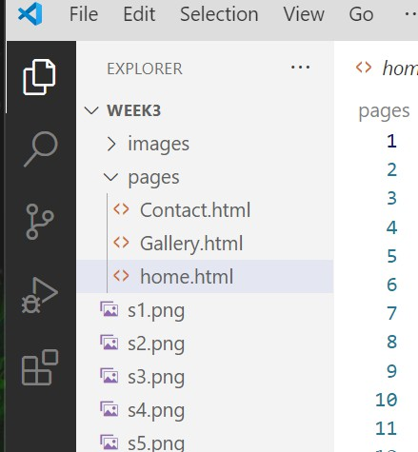

**Step1:Make the same labsecond in bootsrap good way three page Home.html, Gallery.html, Contact.html.**

**Home.html**

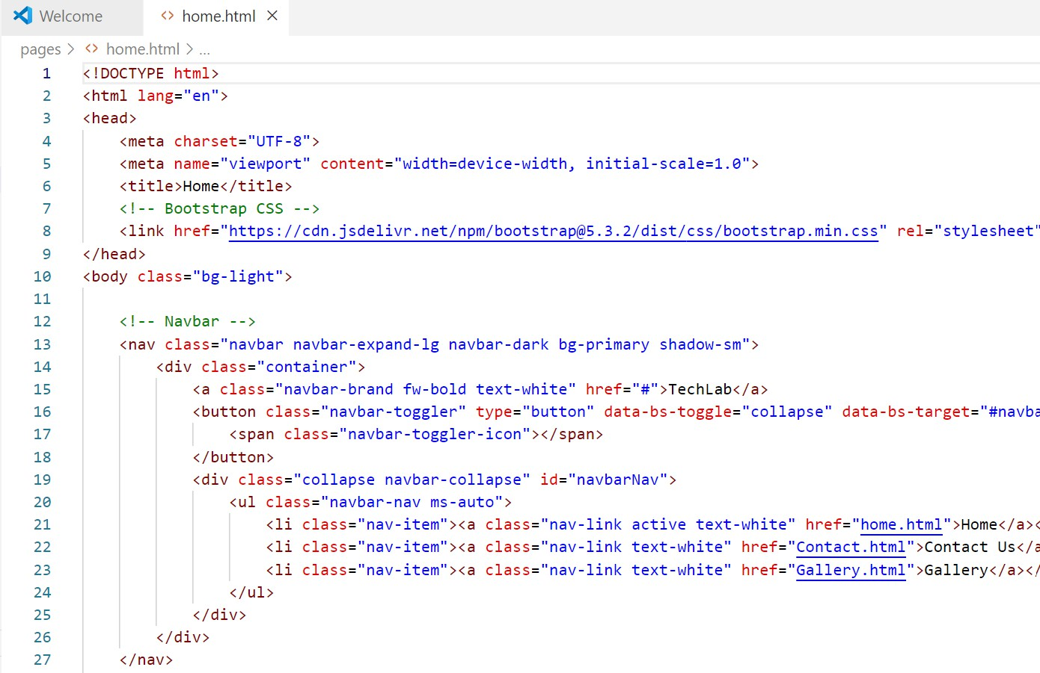

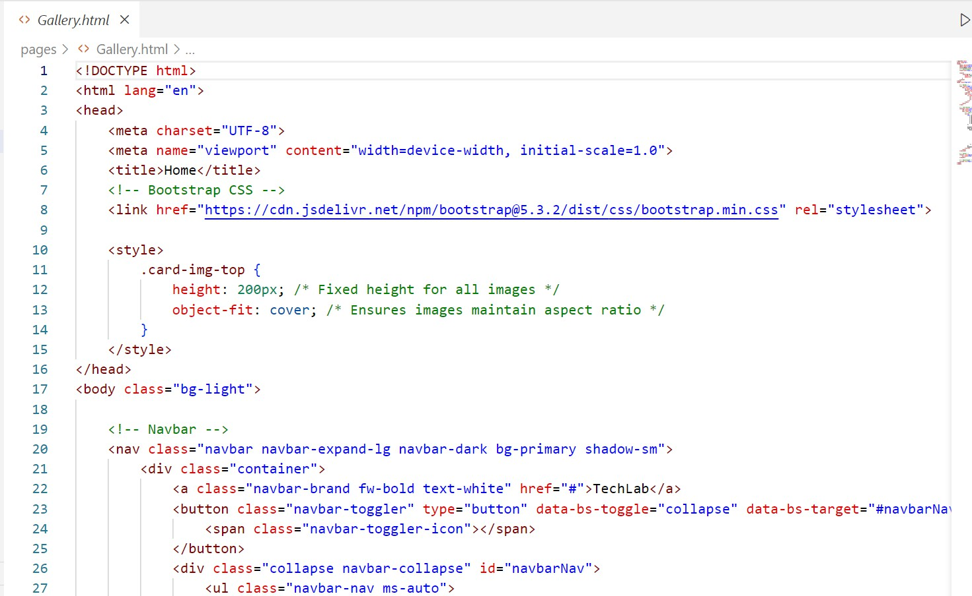**Gallery.html**

**Contact.html**

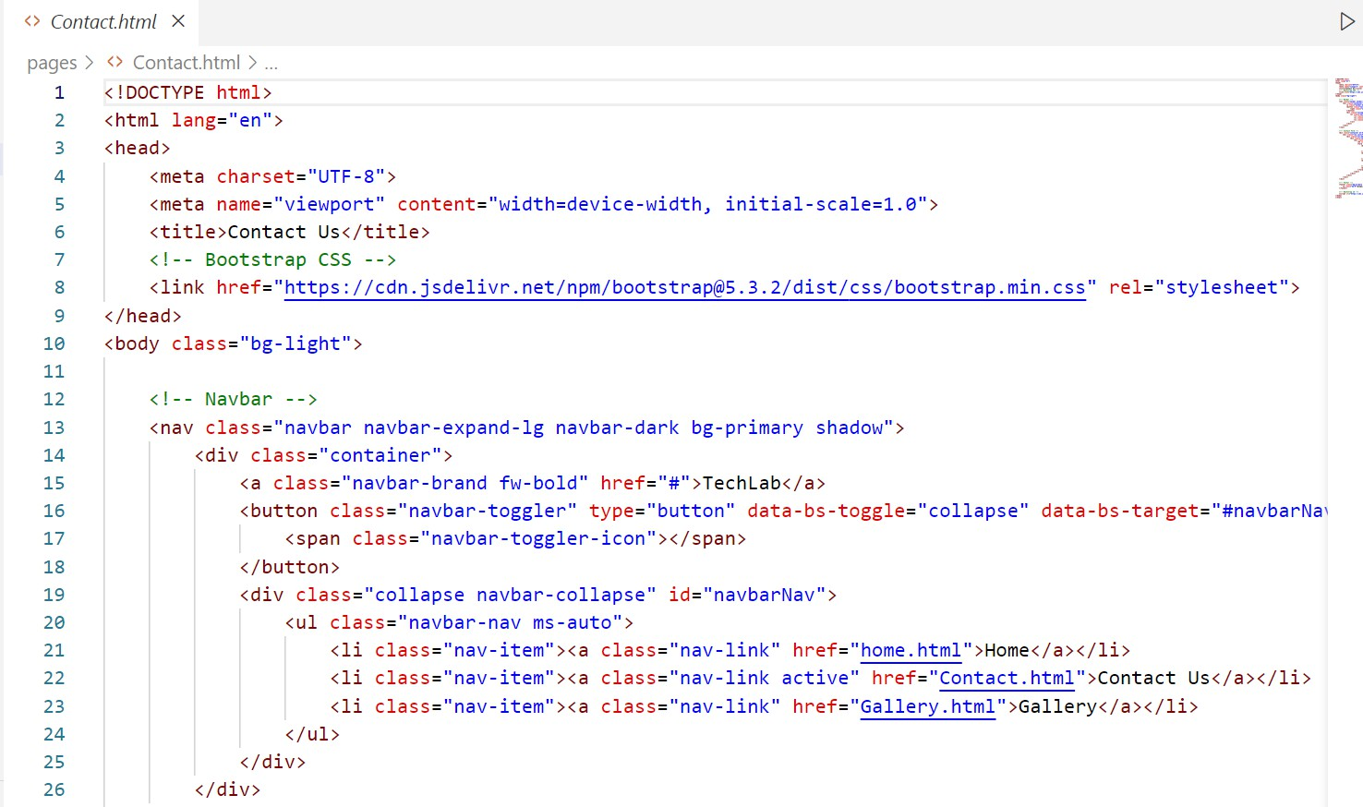

**Step2: Run the project on web browser and Show it:**

**Home**

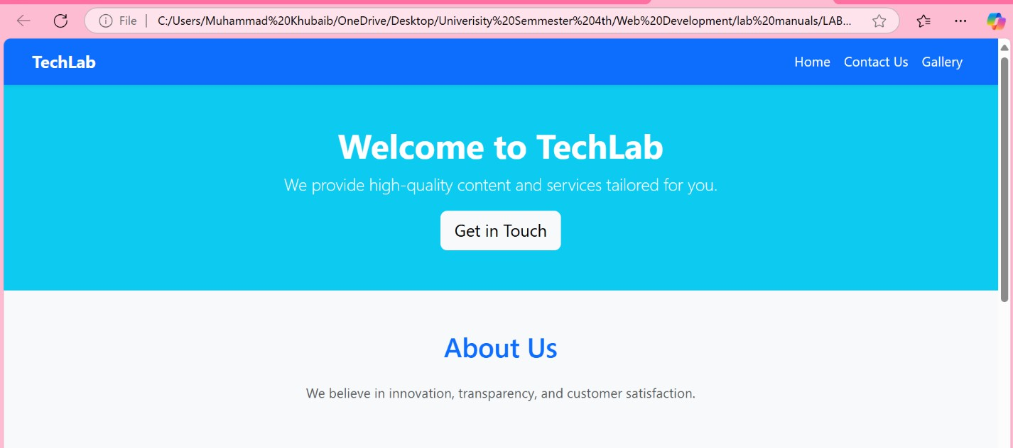

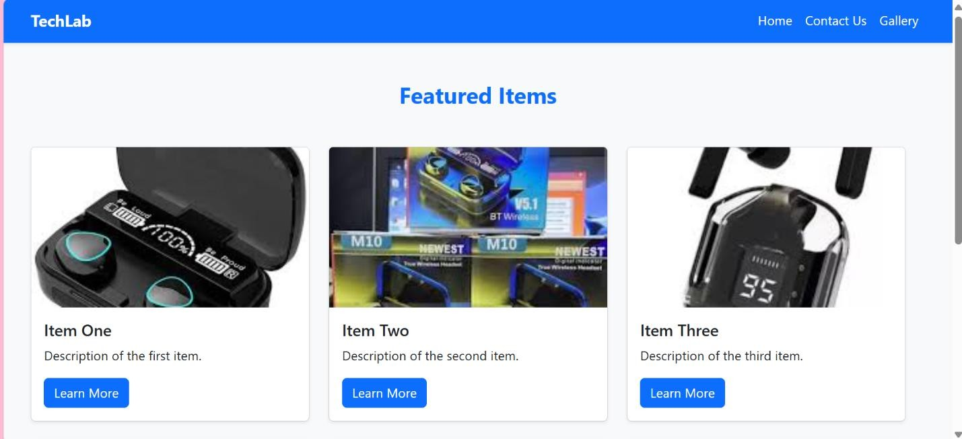

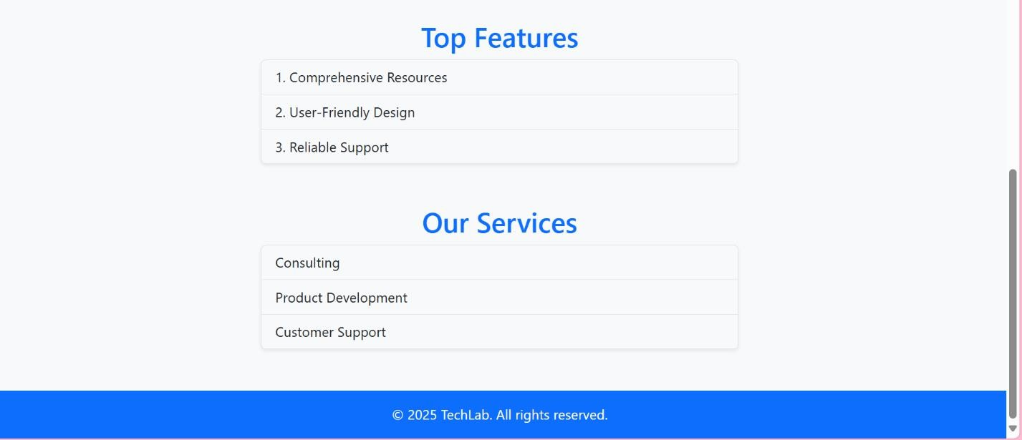

**Contact**

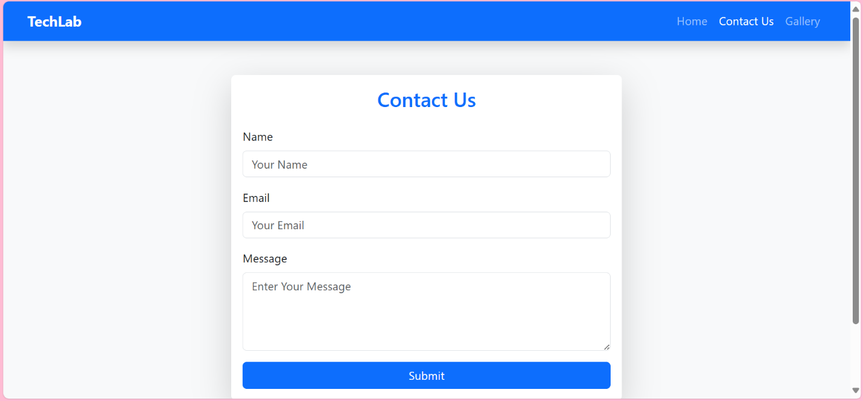

**Gallery**



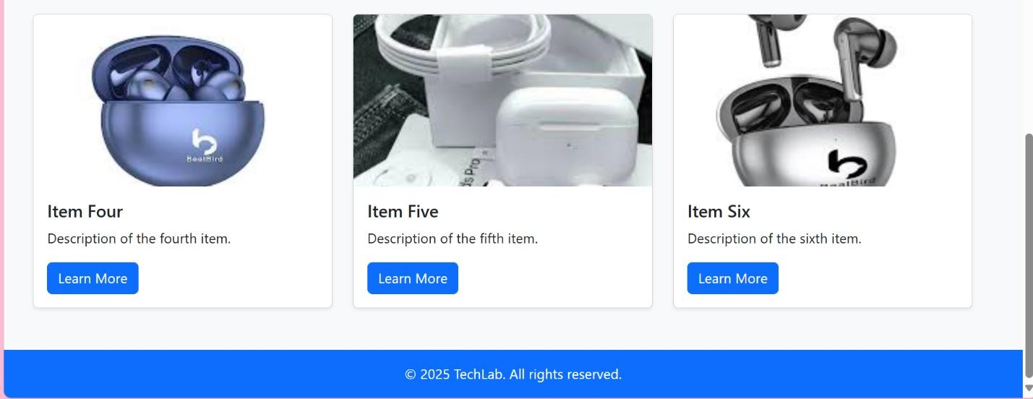



#### GENERALIZED LAB RUBRICS

|  |  |  |  |  |  |  |  |  |
| --- | --- | --- | --- | --- | --- | --- | --- | --- |
| **Domain** | **Component with Taxonomy** | **Above Expectation (4)** | **Meeting Expectation (3)** | **Approaching Expectation (2)** | **Below Expectation (1)** | **Used** | **Weight / 100**  **(Optional)** | **Score (1–4)** |
| **Psychomotor** | **Building (Hardware)** | **Is able to build a given setup neatly and timely using correct hardware components and**  **/ or can reorganize / adapt to new / special**  **requirements** | **Is able to assemble a given setup using correct hardware components after minor revisions** | **Is only able to copy a given setup using correct hardware components** | **Is not able to assemble a given setup using correct hardware components** | ☐ |  |  |
| **Cognitive** | **Recording Measurements (Hardware / Software)** | **Is able to record accurate measurements all the time** | **Is able to record accurate measurements most of the time** | **Is only able to record accurate measurements on some**  **occasions** | **Is unable to record accurate measurements** | ☐ |  |  |
| **Investigation (Software)** | **Is able to formulate**  **/develop theories in addition to evaluating**  **/concluding correctly about investigation parameters by**  **assessing data** | **Is able to evaluate**  **/conclude correctly about investigation parameters by assessing data** | **Is partially able to evaluate**  **/conclude correctly about investigation parameters by assessing data** | **Is unable to comprehend investigation parameters** | ☐ |  |  |
| **Design / Development of Solution (Hardware / Software)** | **Is able to design**  **/ develop the solution of a given problem and add features**  **to it** | **Is able to design**  **/ develop the solution of a given problem** | **Is able to partially design**  **/ develop the solution of a given problem** | **Is unable to partially design / develop the solution of a**  **given problem** | ☐ |  |  |
| **Software Usage (Software)** | **Is adept in the use of software tool and can access advanced features** | **Is able to use the software tool effectively by accessing all the required**  **features** | **Is able to use the software tool but cannot access all the required**  **features** | **Is unable to use the software tool** | ☐ |  |  |
| **Programming Language (Software)** | **Is able to efficiently complete a given task using advanced programming language constructs / methods / commands and/or add features to the**  **original task** | **Is able to complete a given task using required programming language constructs / methods / commands** | **Is able to partially complete a given task** | **Is unable to partially complete a given task** | ☐ |  |  |



**GENERALIZED LAB RUBRICS**

|  |  |  |  |  |  |  |  |  |
| --- | --- | --- | --- | --- | --- | --- | --- | --- |
| **Domain** | **Component with Taxonomy** | **Above Expectation (4)** | **Meeting Expectation (3)** | **Approaching Expectation (2)** | **Below Expectation (1)** | **Used** | **Weight / 100**  **(Optional)** | **Score (1–4)** |
| **Affective** | **Safety Instructions (PLO6)** | **Assesses and complies with all EHS instructions**  **while in lab** | **Assesses and complies with most EHS instructions**  **while in lab** | **Assesses and complies with some EHS instructions**  **while in lab** | **Assesses and complies with few EHS instructions in**  **lab** | ☐ |  |  |
| **Professional Ethics (PLO8)** | **Exhibits exemplary professional ethics while writing lab reports and dealing with fellow students, lab staff and instructor all the time** | **Exhibits professional ethics while writing lab reports and dealing with fellow students, lab staff and instructor all the time** | **Makes an effort to exhibit professional ethics while writing lab reports and dealing with fellow students, lab staff and instructor all the time** | **Does not exhibit professional ethics while writing lab reports and dealing with fellow students, lab staff and**  **instructor all the time** | ☐ |  |  |
| **Contribution (PLO9)** | **Consistently shows full preparation by completing all agreed tasks and provides additional resources for the group and**  **work quality is excellent** | **Consistently shows full preparation by completing all agreed tasks and work requires little or no revisions** | **Shows some preparation which is mostly at superficial level in completing a task and work requires much revisions and editing** | **Shows very little or no preparation in completing a task and work quality is poor** | ☐ |  |  |
| **Attitude (PLO9)** | **Internalized positive behavior and encourages and helps other team members** | **Consistent positive behavior most of the time towards other team members** | **Neither helpful nor damaging and shows disinterest in the performance of**  **others** | **Discouraging behavior towards other team members** | ☐ |  |  |
| **Report Writing (PLO10)** | **Report on all relevant sections related to the lab tasks is completed accurately, meeting the requirements, in prescribed time and with good language skills** | **Report on all relevant sections related to the lab tasks is completed but few deficiencies are present in terms of accuracy / meeting the requirements / prescribed time**  **/ good language skills** | **Report on all relevant sections related to the lab tasks is completed but many deficiencies are present in terms of accuracy / meeting the requirements / prescribed time**  **/ good language skills** | **Report on all relevant sections related to the lab tasks is not completed** | ☐ |  |  |
| **Lab Task Management (PLO11)** | **Manages tasks well within given timeframe** | **Manages tasks within given timeframe** | **Manages tasks in an extended timeframe** | **Does not manage tasks even in extended**  **timeframes** | ☐ |  |  |



### LAB 04

**Introduction to .Net core MVC design pattern Convert your HTML website into .net core MVC.**

**Web Development**

**File Structure:**

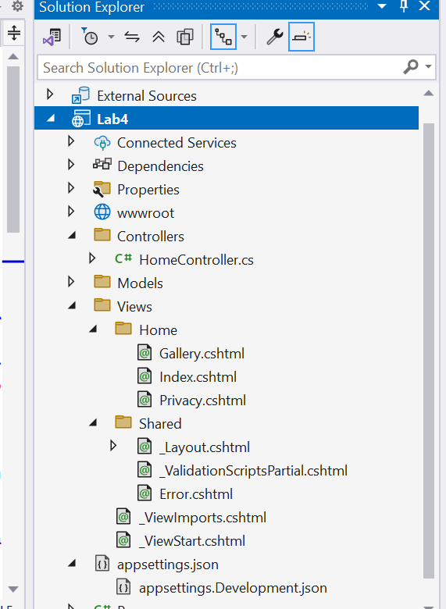

In the Home Controller define Action of three file Index.cshtml. Contact.cshtml, Privacy.cshtml.



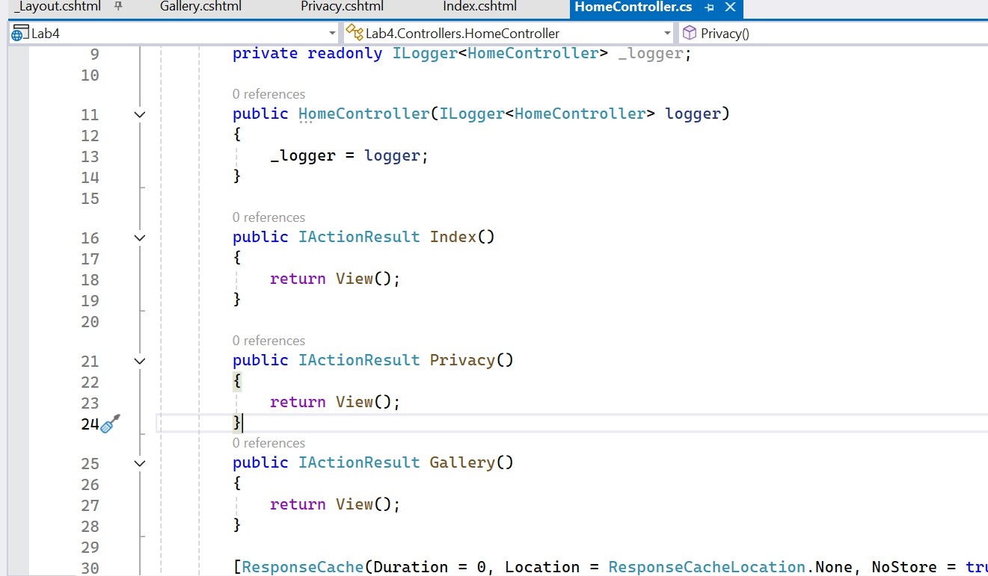

**Index.cshtml for home page:**

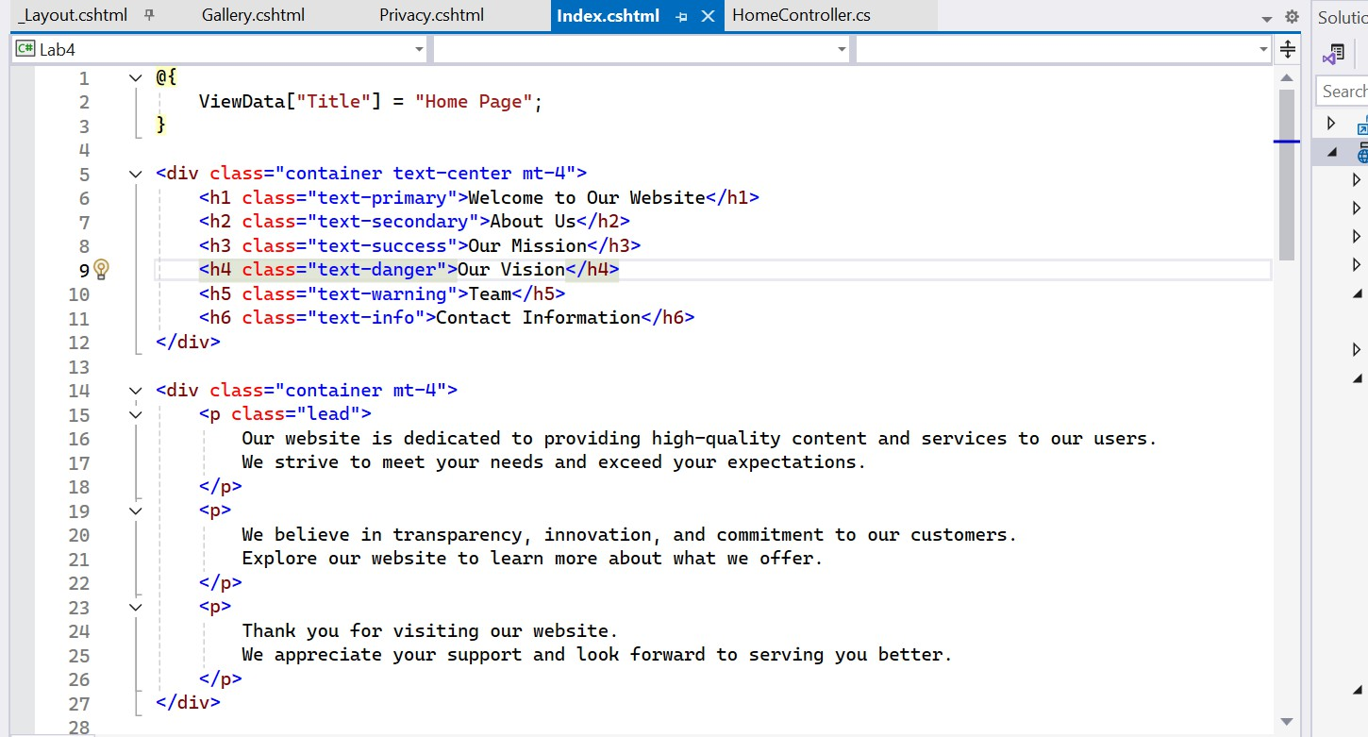

**Gallery.cshtml for Gallery page:**



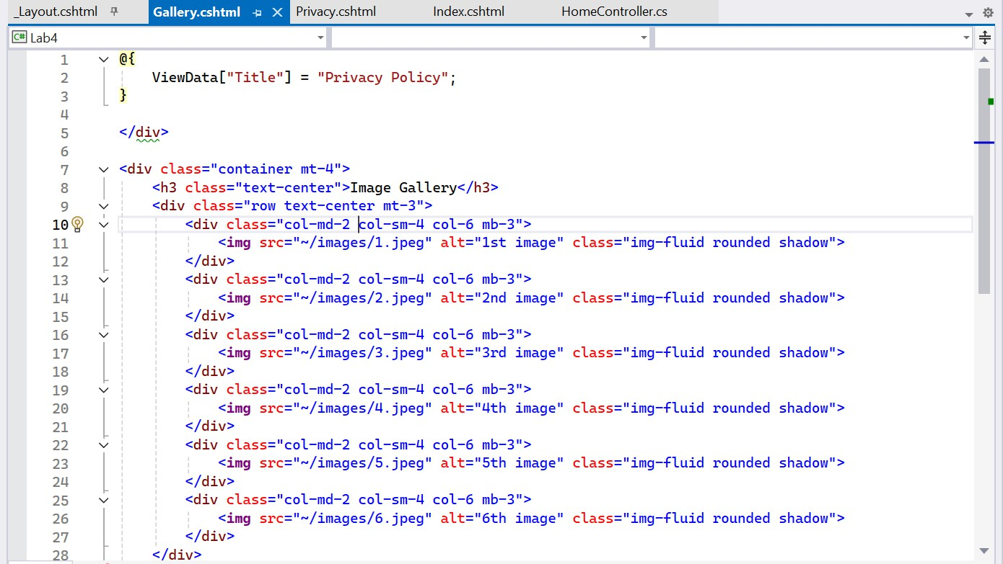

**Privacy.cshtml for Contact page:**

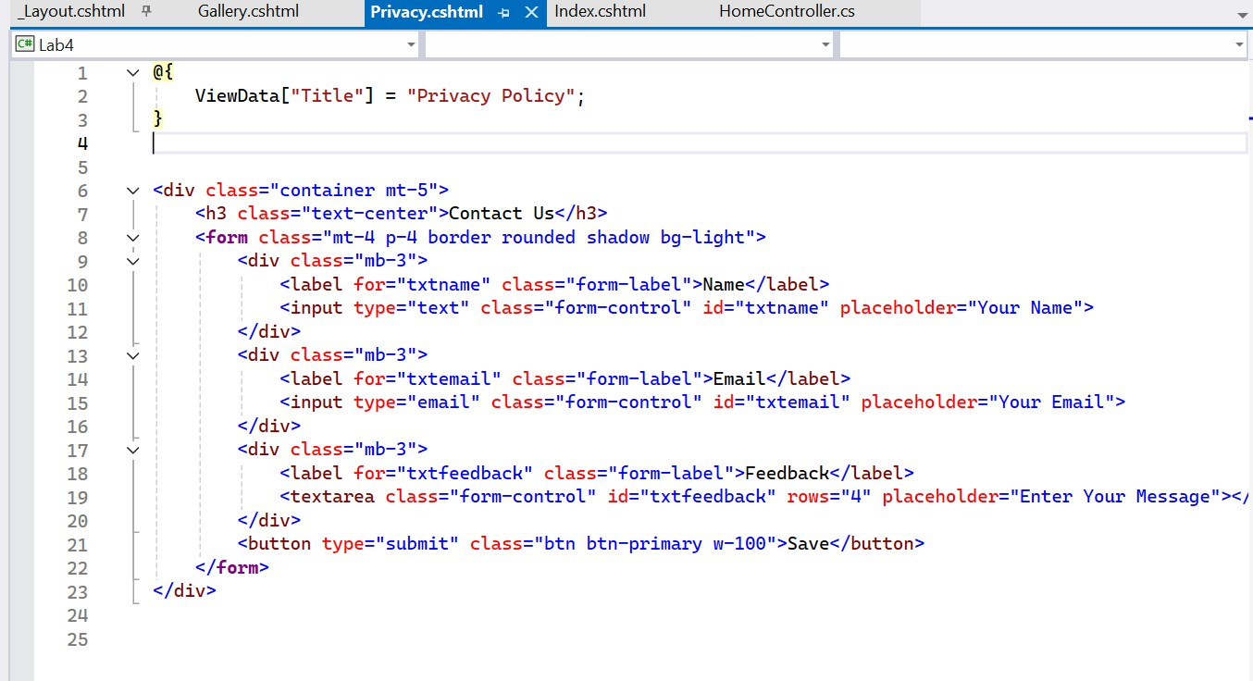

**Layout.cshtml for Navbar and Footer:**



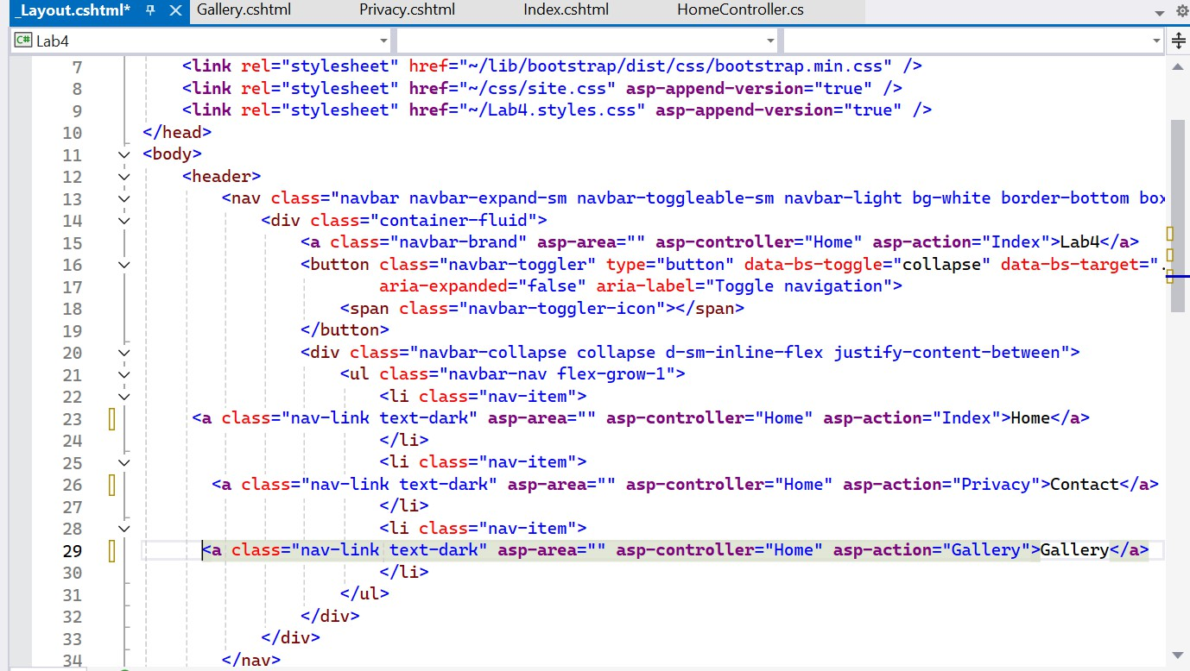

**OUTPUT OF Home page:**



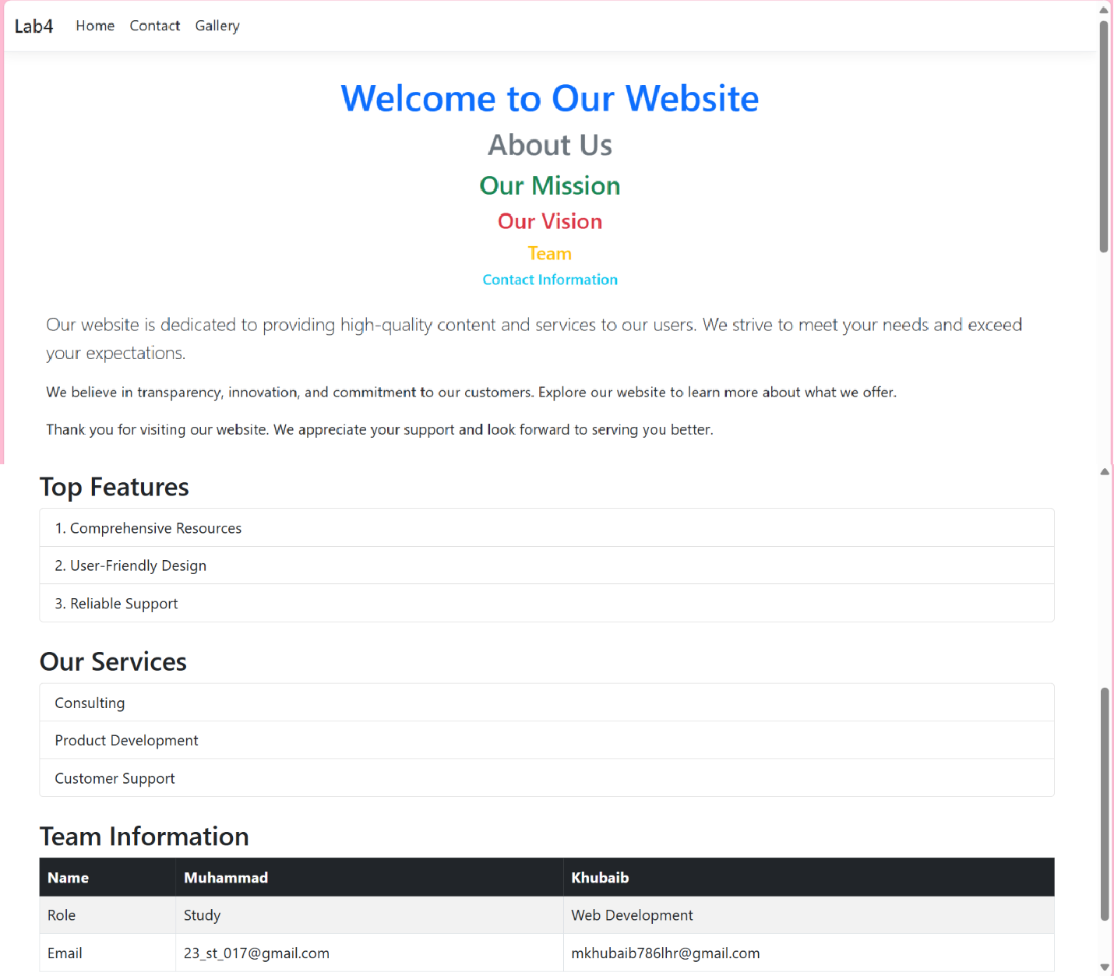

**OUTPUT OF Contact Page:**



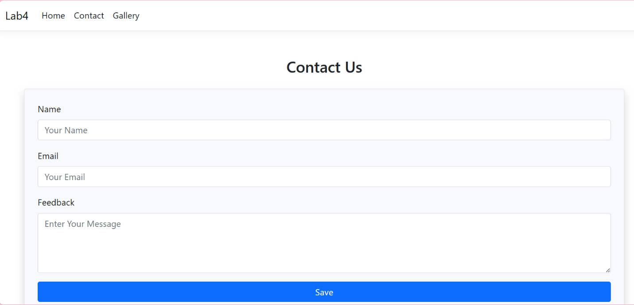

**OUTPUT OF Gallery Page:**

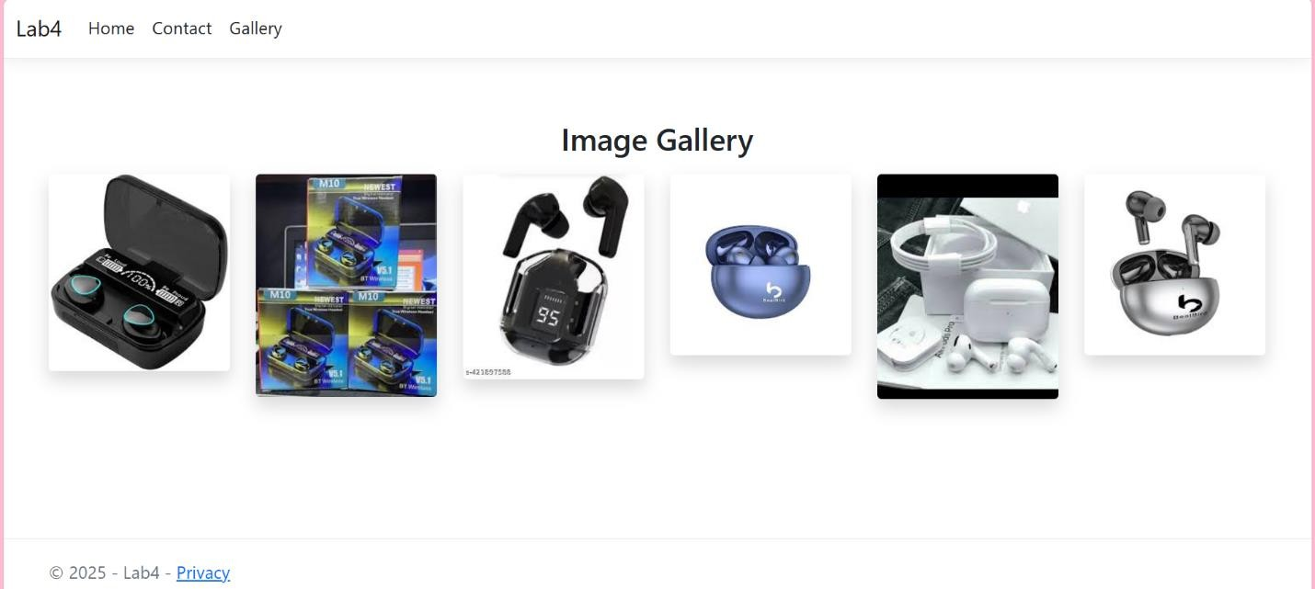



**GENERALIZED LAB RUBRICS**

|  |  |  |  |  |  |  |  |  |
| --- | --- | --- | --- | --- | --- | --- | --- | --- |
| **Domain** | **Component with Taxonomy** | **Above Expectation (4)** | **Meeting Expectation (3)** | **Approaching Expectation (2)** | **Below Expectation (1)** | **Used** | **Weight / 100**  **(Optional)** | **Score (1–4)** |
| **Psychomotor** | **Building (Hardware)** | **Is able to build a given setup neatly and timely using correct hardware components and / or can reorganize / adapt to new / special requirements** | **Is able to assemble a given setup using correct hardware components after minor revisions** | **Is only able to copy a given setup using correct hardware components** | **Is not able to assemble a given setup using correct hardware components** | ☐ |  |  |
| **Cognitive** | **Recording Measurements (Hardware / Software)** | **Is able to record accurate measurements all the time** | **Is able to record accurate measurements most of the time** | **Is only able to record accurate measurements on some occasions** | **Is unable to record accurate measurements** | ☐ |  |  |
| **Investigation (Software)** | **Is able to formulate**  **/develop theories in addition to evaluating**  **/concluding correctly about investigation parameters by assessing data** | **Is able to evaluate**  **/conclude correctly about investigation parameters by assessing data** | **Is partially able to evaluate /conclude correctly about investigation parameters by assessing data** | **Is unable to comprehend investigation parameters** | ☐ |  |  |
| **Design / Development of Solution (Hardware / Software)** | **Is able to design / develop the solution of a given problem and add features to it** | **Is able to design / develop the solution of a given problem** | **Is able to partially design / develop the solution of a given problem** | **Is unable to partially design / develop the solution of a given problem** | ☐ |  |  |
| **Software Usage (Software)** | **Is adept in the use of software tool and can access advanced features** | **Is able to use the software tool effectively by accessing all the required features** | **Is able to use the software tool but cannot access all the required features** | **Is unable to use the software tool** | ☐ |  |  |
| **Programming Language (Software)** | **Is able to efficiently complete a given task using advanced programming language constructs / methods / commands and/or add features to the original task** | **Is able to complete a given task using required programming language constructs / methods / commands** | **Is able to partially complete a given task** | **Is unable to partially complete a given task** | ☐ |  |  |



**GENERALIZED LAB RUBRICS**

|  |  |  |  |  |  |  |  |  |
| --- | --- | --- | --- | --- | --- | --- | --- | --- |
| **Domain** | **Component with Taxonomy** | **Above Expectation (4)** | **Meeting Expectation (3)** | **Approaching Expectation (2)** | **Below Expectation (1)** | **Used** | **Weight / 100**  **(Optional)** | **Score (1–4)** |
| **Affective** | **Safety Instructions (PLO6)** | **Assesses and complies with all EHS instructions while in lab** | **Assesses and complies with most EHS instructions while in lab** | **Assesses and complies with some EHS instructions while in lab** | **Assesses and complies with few EHS instructions in lab** | ☐ |  |  |
| **Professional Ethics (PLO8)** | **Exhibits exemplary professional ethics while writing lab reports and dealing with fellow students, lab staff and instructor all the time** | **Exhibits professional ethics while writing lab reports and dealing with fellow students, lab staff and instructor all the time** | **Makes an effort to exhibit professional ethics while writing lab reports and dealing with fellow students, lab staff and instructor all the time** | **Does not exhibit professional ethics while writing lab reports and dealing with fellow students, lab staff and instructor all the time** | ☐ |  |  |
| **Contribution (PLO9)** | **Consistently shows full preparation by completing all agreed tasks and provides additional resources for the group and work quality is excellent** | **Consistently shows full preparation by completing all agreed tasks and work requires little or no revisions** | **Shows some preparation which is mostly at superficial level in completing a task and work requires much revisions and editing** | **Shows very little or no preparation in completing a task and work quality is poor** | ☐ |  |  |
| **Attitude (PLO9)** | **Internalized positive behavior and encourages and helps other team members** | **Consistent positive behavior most of the time towards other team members** | **Neither helpful nor damaging and shows disinterest in the performance of others** | **Discouraging behavior towards other team members** | ☐ |  |  |
| **Report Writing (PLO10)** | **Report on all relevant sections related to the lab tasks is completed accurately, meeting the requirements, in prescribed time and with good language skills** | **Report on all relevant sections related to the lab tasks is completed but few deficiencies are present in terms of accuracy / meeting the requirements / prescribed time / good language skills** | **Report on all relevant sections related to the lab tasks is completed but many deficiencies are present in terms of accuracy / meeting the requirements / prescribed time / good language skills** | **Report on all relevant sections related to the lab tasks is not completed** | ☐ |  |  |
| **Lab Task Management (PLO11)** | **Manages tasks well within given timeframe** | **Manages tasks within given timeframe** | **Manages tasks in an extended timeframe** | **Does not manage tasks even in extended timeframes** | ☐ |  |  |



### LAB 05

**Implement and run Add CRUD operations into your website by using Asp.net core mvc.**

**Web Development**

**Step1:**

**Create the application name as Employee Management.**

**File Structure of Employee Management System:**

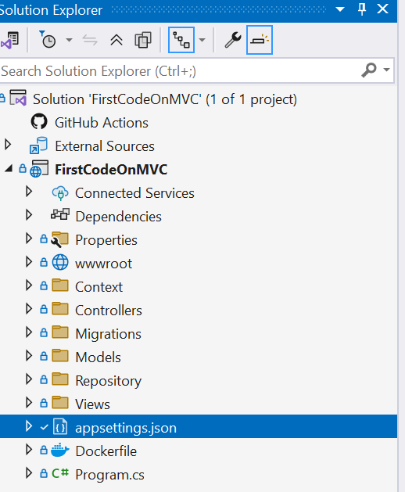

## Display file :



**Model CODE:**

namespace FirstCodeOnMVC.Models

{

public class Employee

{

public int Id { get; set; }

public string Name { get; set; } public int Salary { get; set; } public string City { get; set; }

}

}

**Controller:**

using System.Diagnostics; using FirstCodeOnMVC.Models;

using Microsoft.AspNetCore.Mvc;

namespace FirstCodeOnMVC.Controllers

{

public class HomeController : Controller

{

private readonly ILogger<HomeController> _logger;

public HomeController(ILogger<HomeController> logger)

{

_logger = logger;

}

public IActionResult Index()

{

return View();

}

public IActionResult Privacy()

{

return View();

}

[ResponseCache(Duration = 0, Location = ResponseCacheLocation.None, NoStore = true)] public IActionResult Error()

{

return View(new ErrorViewModel { RequestId = Activity.Current?.Id ??

HttpContext.TraceIdentifier });

}

}}

**Program.cs**

using FirstCodeOnMVC.Context; using FirstCodeOnMVC.Repository; using Microsoft.EntityFrameworkCore;



var builder = WebApplication.CreateBuilder(args);

// Add services to the container. builder.Services.AddControllersWithViews();

builder.Services.AddScoped<IEmployeeRepository, SqlEmployeeRepository>(); builder.Services.AddScoped<EmployeeDbContext, EmployeeDbContext>();

builder.Services.AddDbContext<EmployeeDbContext>(options => options.UseSqlServer(builder.Configuration.GetConnectionString("DefaultConnection")));

var app = builder.Build();

// Configure the HTTP request pipeline. if (!app.Environment.IsDevelopment())

{

app.UseExceptionHandler("/Home/Error");

// The default HSTS value is 30 days. You may want to change this for production scenarios, see https://aka.ms/aspnetcore-hsts.

app.UseHsts();

}

app.UseHttpsRedirection(); app.UseStaticFiles();

app.UseRouting(); app.UseAuthorization(); app.MapControllerRoute(

name: "default",

pattern: "{controller=Employee}/{action=Index}/{id?}"); app.Run();

**View:**



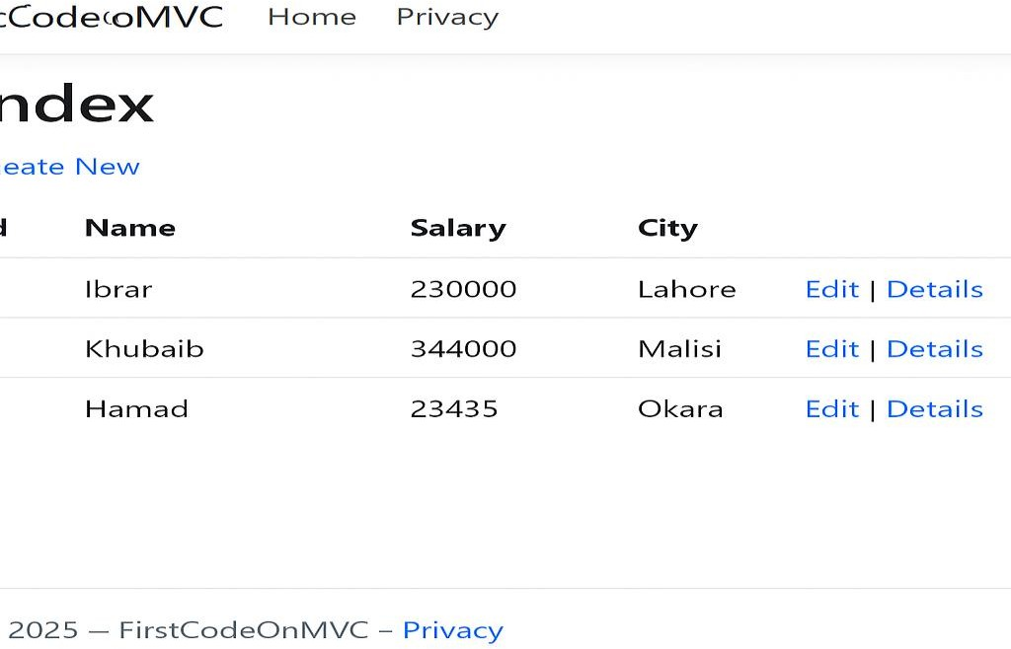

**Create:**

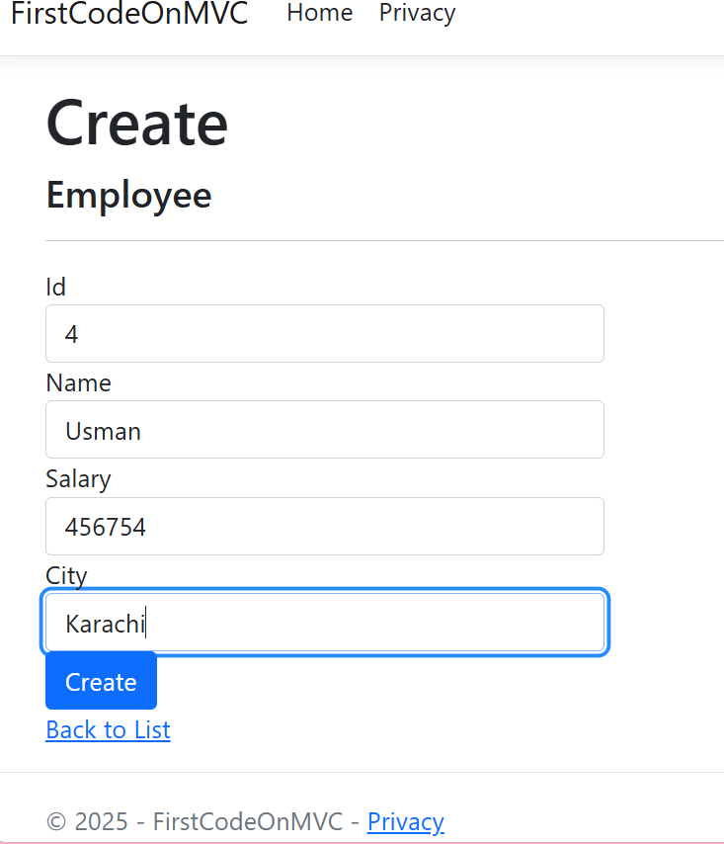

**Update/Edit:**



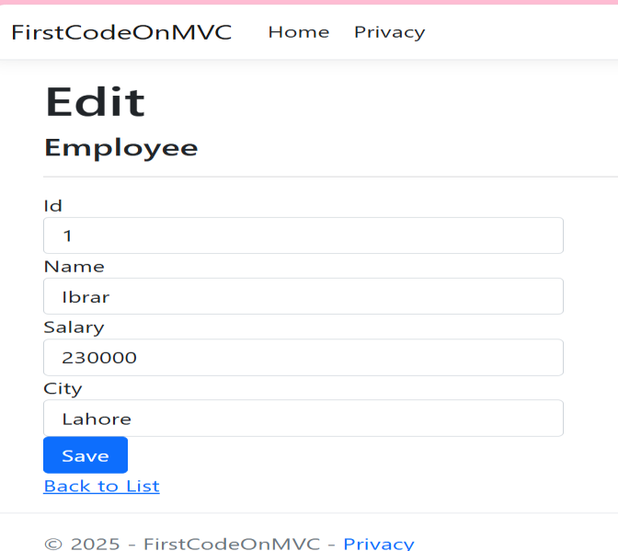

**Delete**

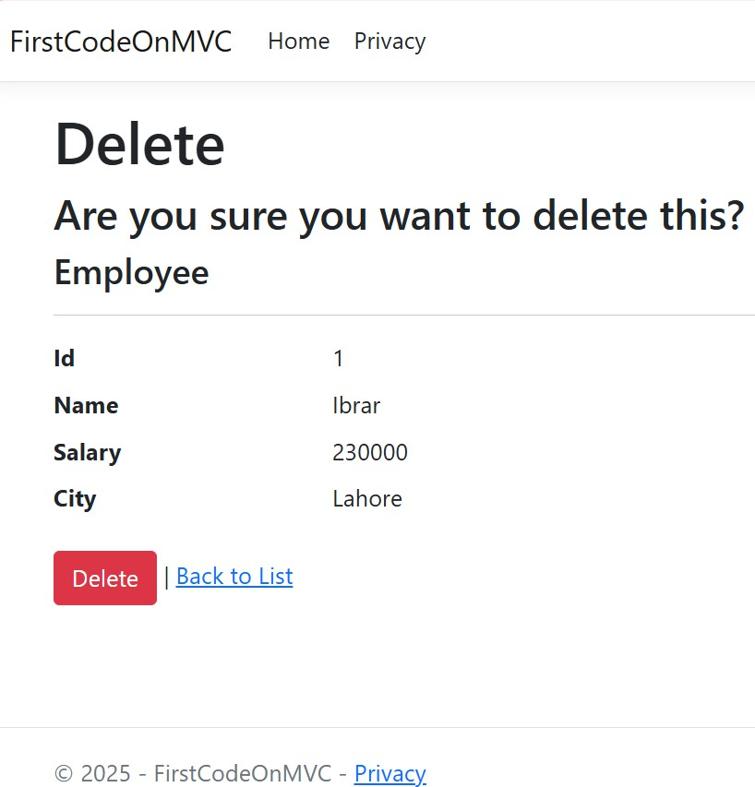



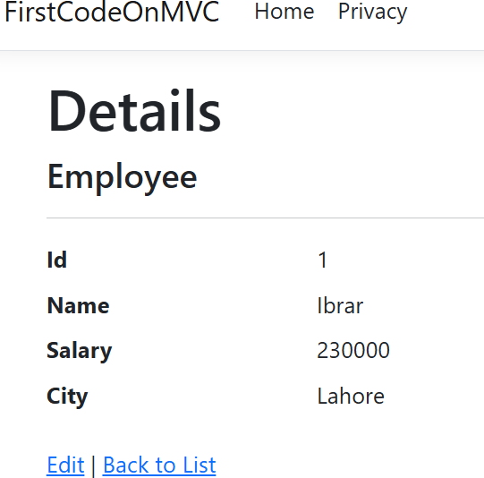



**GENERALIZED LAB RUBRICS**

|  |  |  |  |  |  |  |  |  |
| --- | --- | --- | --- | --- | --- | --- | --- | --- |
| **Domain** | **Component with Taxonomy** | **Above Expectation (4)** | **Meeting Expectation (3)** | **Approaching Expectation (2)** | **Below Expectation (1)** | **Used** | **Weight / 100**  **(Optional)** | **Score (1–4)** |
| **Psychomotor** | **Building (Hardware)** | **Is able to build a given setup neatly and timely using correct hardware components and / or can reorganize / adapt to new / special requirements** | **Is able to assemble a given setup using correct hardware components after minor revisions** | **Is only able to copy a given setup using correct hardware components** | **Is not able to assemble a given setup using correct hardware components** | ☐ |  |  |
| **Cognitive** | **Recording Measurements (Hardware / Software)** | **Is able to record accurate measurements all the time** | **Is able to record accurate measurements most of the time** | **Is only able to record accurate measurements on some occasions** | **Is unable to record accurate measurements** | ☐ |  |  |
| **Investigation (Software)** | **Is able to formulate**  **/develop theories in addition to evaluating**  **/concluding correctly about investigation parameters by assessing data** | **Is able to evaluate**  **/conclude correctly about investigation parameters by assessing data** | **Is partially able to evaluate /conclude correctly about investigation parameters by assessing data** | **Is unable to comprehend investigation parameters** | ☐ |  |  |
| **Design / Development of Solution (Hardware / Software)** | **Is able to design / develop the solution of a given problem and add features to it** | **Is able to design / develop the solution of a given problem** | **Is able to partially design / develop the solution of a given problem** | **Is unable to partially design / develop the solution of a given problem** | ☐ |  |  |
| **Software Usage (Software)** | **Is adept in the use of software tool and can access advanced features** | **Is able to use the software tool effectively by accessing all the required features** | **Is able to use the software tool but cannot access all the required features** | **Is unable to use the software tool** | ☐ |  |  |
| **Programming Language (Software)** | **Is able to efficiently complete a given task using advanced programming language constructs / methods / commands and/or add features to the original task** | **Is able to complete a given task using required programming language constructs / methods / commands** | **Is able to partially complete a given task** | **Is unable to partially complete a given task** | ☐ |  |  |



**GENERALIZED LAB RUBRICS**

|  |  |  |  |  |  |  |  |  |
| --- | --- | --- | --- | --- | --- | --- | --- | --- |
| **Domain** | **Component with Taxonomy** | **Above Expectation (4)** | **Meeting Expectation (3)** | **Approaching Expectation (2)** | **Below Expectation (1)** | **Used** | **Weight / 100**  **(Optional)** | **Score (1–4)** |
| **Affective** | **Safety Instructions (PLO6)** | **Assesses and complies with all EHS instructions while in lab** | **Assesses and complies with most EHS instructions while in lab** | **Assesses and complies with some EHS instructions while in lab** | **Assesses and complies with few EHS instructions in lab** | ☐ |  |  |
| **Professional Ethics (PLO8)** | **Exhibits exemplary professional ethics while writing lab reports and dealing with fellow students, lab staff and instructor all the time** | **Exhibits professional ethics while writing lab reports and dealing with fellow students, lab staff and instructor all the time** | **Makes an effort to exhibit professional ethics while writing lab reports and dealing with fellow students, lab staff and instructor all the time** | **Does not exhibit professional ethics while writing lab reports and dealing with fellow students, lab staff and instructor all the time** | ☐ |  |  |
| **Contribution (PLO9)** | **Consistently shows full preparation by completing all agreed tasks and provides additional resources for the group and work quality is excellent** | **Consistently shows full preparation by completing all agreed tasks and work requires little or no revisions** | **Shows some preparation which is mostly at superficial level in completing a task and work requires much revisions and editing** | **Shows very little or no preparation in completing a task and work quality is poor** | ☐ |  |  |
| **Attitude (PLO9)** | **Internalized positive behavior and encourages and helps other team members** | **Consistent positive behavior most of the time towards other team members** | **Neither helpful nor damaging and shows disinterest in the performance of others** | **Discouraging behavior towards other team members** | ☐ |  |  |
| **Report Writing (PLO10)** | **Report on all relevant sections related to the lab tasks is completed accurately, meeting the requirements, in prescribed time and with good language skills** | **Report on all relevant sections related to the lab tasks is completed but few deficiencies are present in terms of accuracy / meeting the requirements / prescribed time / good language skills** | **Report on all relevant sections related to the lab tasks is completed but many deficiencies are present in terms of accuracy / meeting the requirements / prescribed time / good language skills** | **Report on all relevant sections related to the lab tasks is not completed** | ☐ |  |  |
| **Lab Task Management (PLO11)** | **Manages tasks well within given timeframe** | **Manages tasks within given timeframe** | **Manages tasks in an extended timeframe** | **Does not manage tasks even in extended timeframes** | ☐ |  |  |

### LAB 06

**Project: Create a simple front-end website using the technologies learned in previous labs.**

**Web Development**

# Website Name: Amazon

**File Structure :**

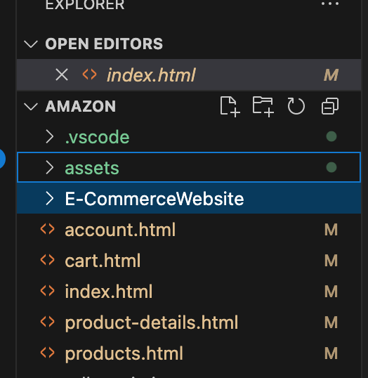

**CODE OF Index.html:**

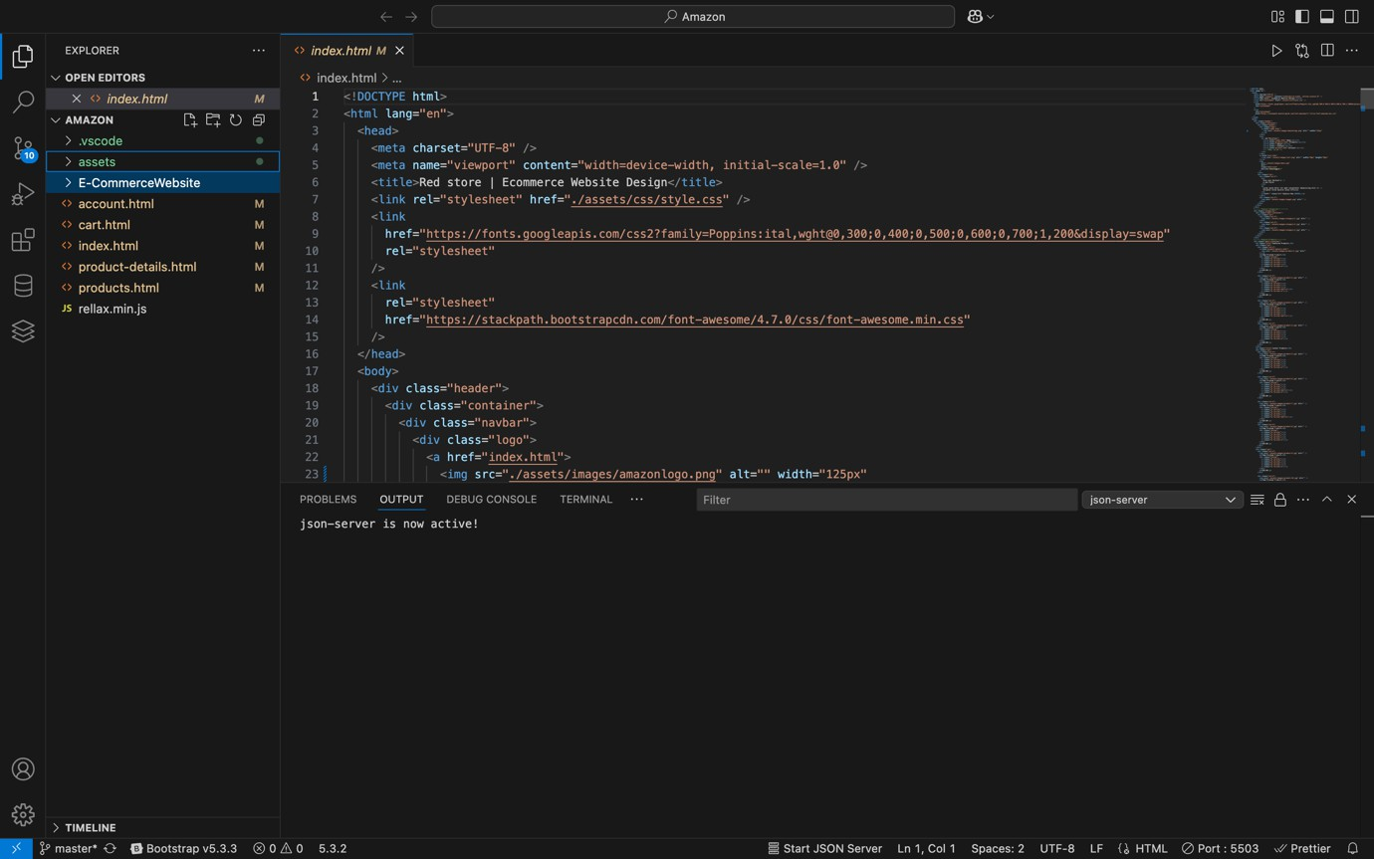

### OUTPUT:

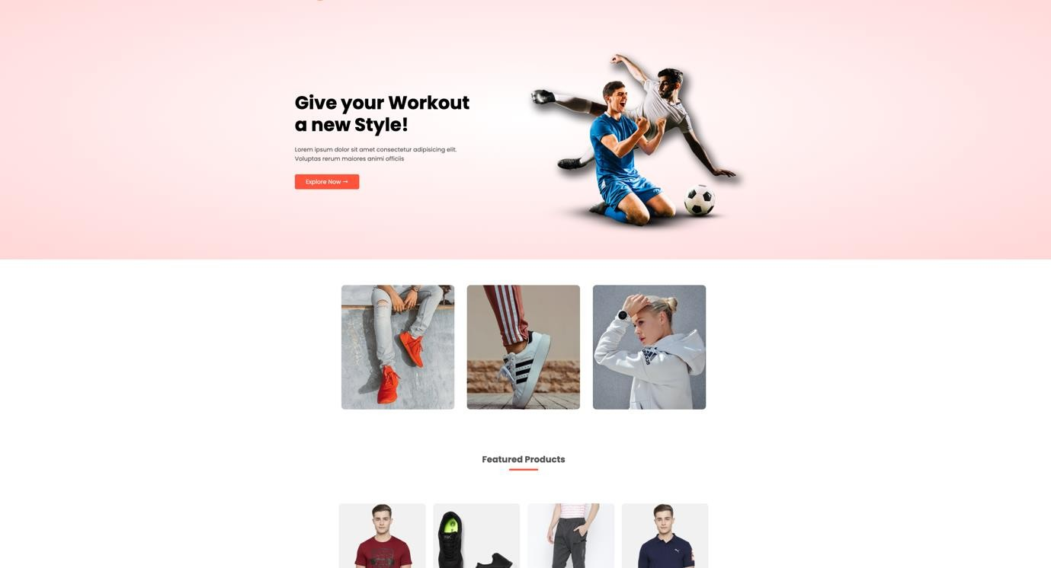

**CODE OF Product Details:**

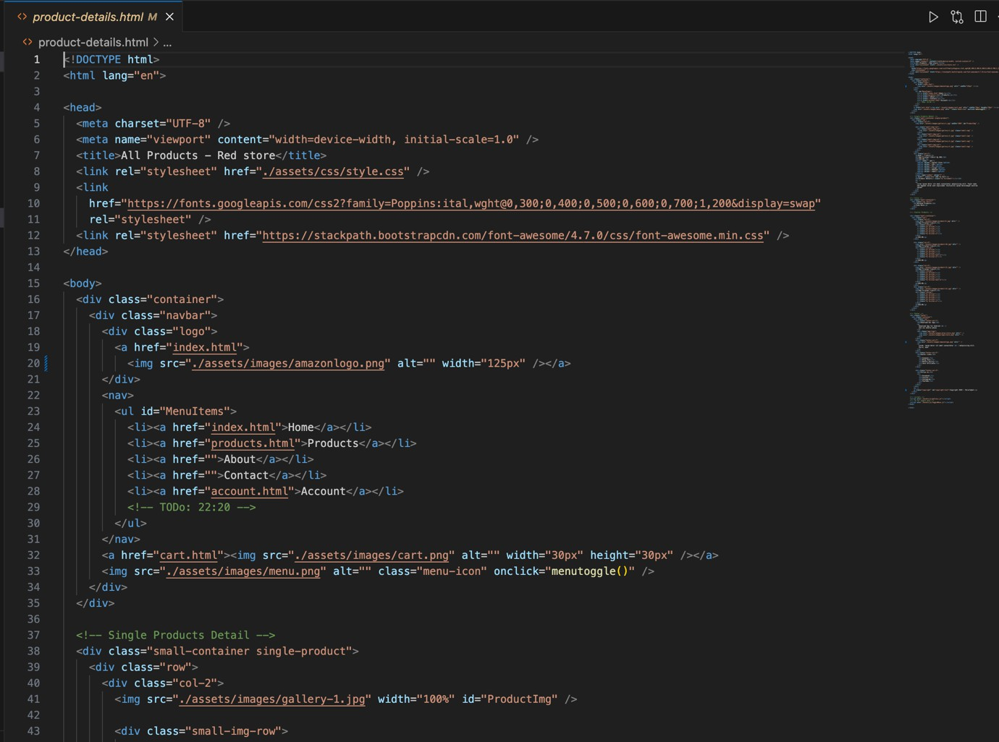

**OUTPUT:**

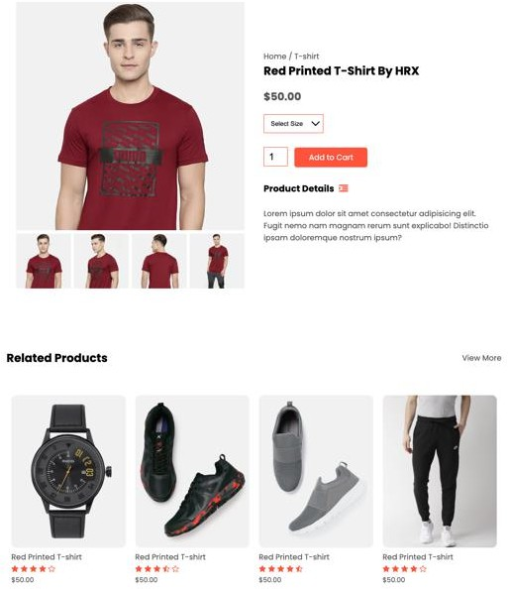

## Account-Details:

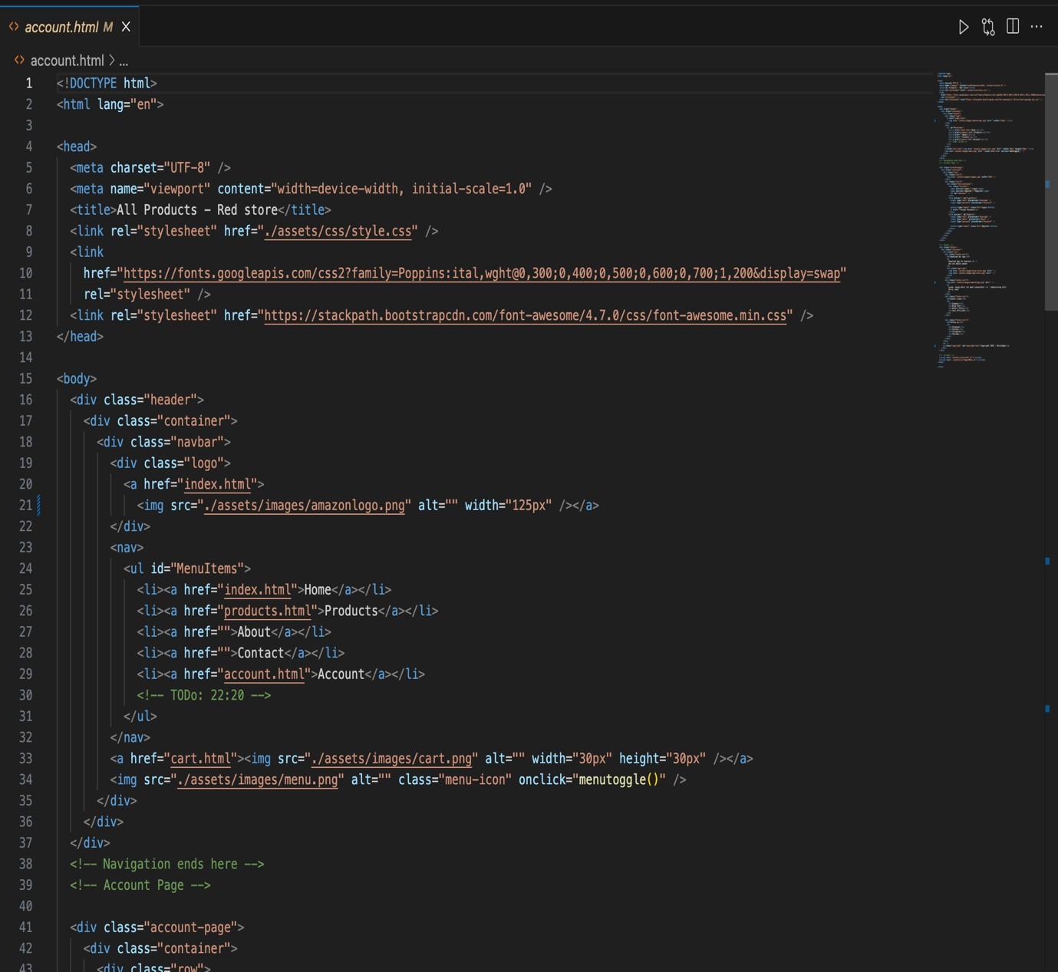

### OUTPUT:

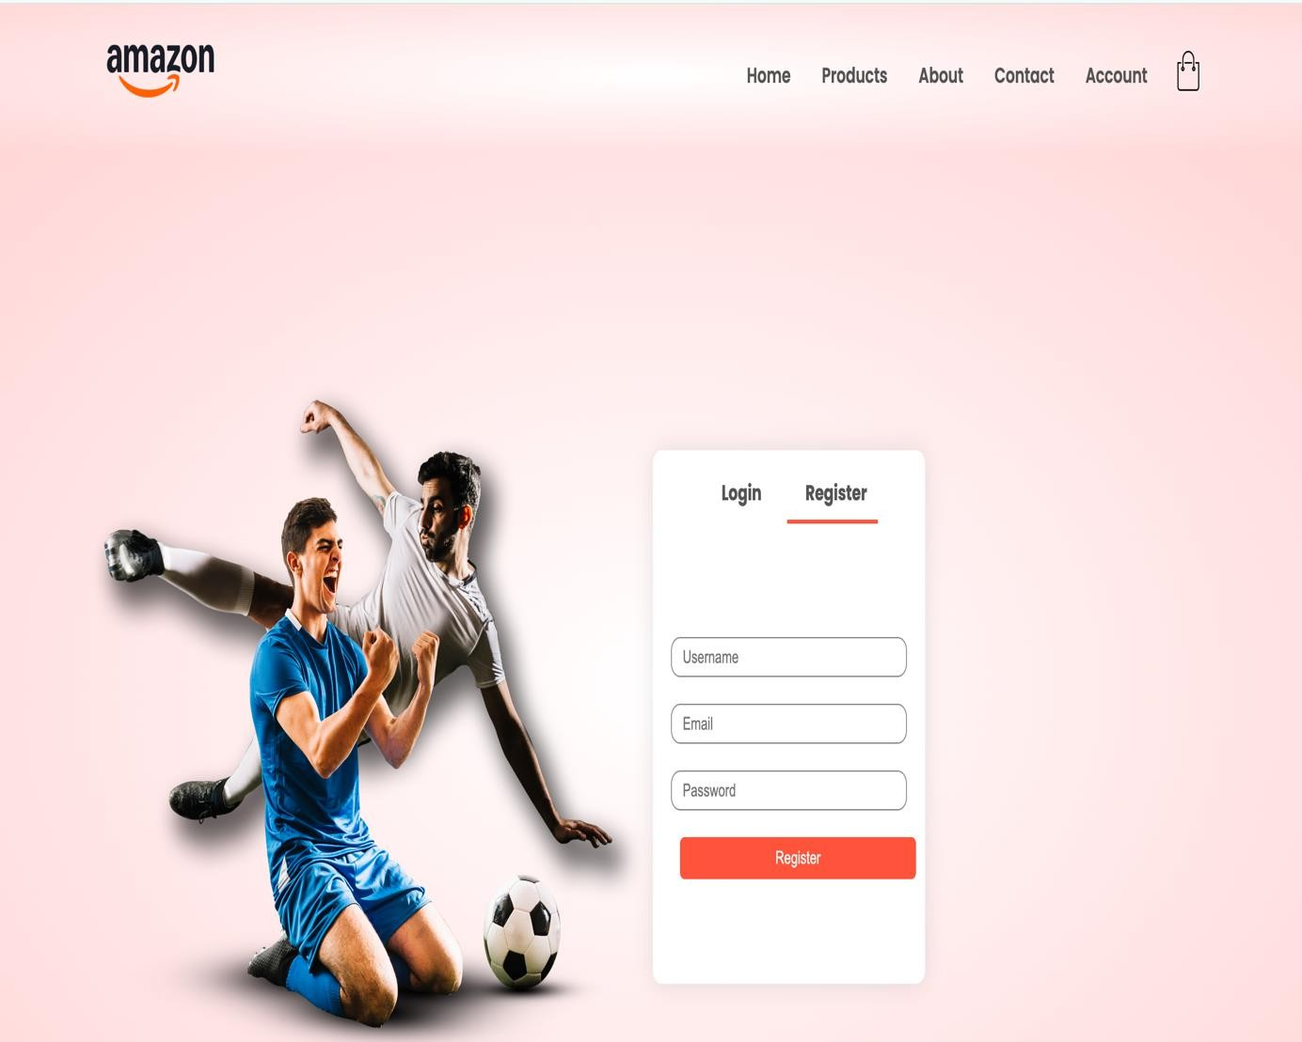

**GENERALIZED LAB RUBRICS**

|  |  |  |  |  |  |  |  |  |
| --- | --- | --- | --- | --- | --- | --- | --- | --- |
| **Domain** | **Component with Taxonomy** | **Above Expectation**  **(4)** | **Meeting Expectation**  **(3)** | **Approaching Expectation**  **(2)** | **Below Expectation**  **(1)** | **Used** | **Weight / 100**  **(Optional)** | **Score (1–4)** |
| **Psychomotor** | **Building (Hardware)** | **Is able to build a given setup neatly and timely using correct hardware components and**  **/ or can reorganize / adapt to new / special**  **requirements** | **Is able to assemble a given setup using correct hardware components after minor revisions** | **Is only able to copy a given setup using correct hardware components** | **Is not able to assemble a given setup using correct hardware components** | ☐ |  |  |
| **Cognitive** | **Recording Measurements (Hardware / Software)** | **Is able to record accurate measurements all the time** | **Is able to record accurate measurements most of the time** | **Is only able to record accurate measurements on some**  **occasions** | **Is unable to record accurate measurements** | ☐ |  |  |
| **Investigation (Software)** | **Is able to formulate**  **/develop theories in addition to evaluating**  **/concluding correctly about investigation parameters by**  **assessing data** | **Is able to evaluate**  **/conclude correctly about investigation parameters by assessing data** | **Is partially able to evaluate**  **/conclude correctly about investigation parameters by assessing data** | **Is unable to comprehend investigation parameters** | ☐ |  |  |
| **Design / Development of Solution (Hardware / Software)** | **Is able to design / develop the solution of a given problem and add features**  **to it** | **Is able to design**  **/ develop the solution of a given problem** | **Is able to partially design**  **/ develop the solution of a given problem** | **Is unable to partially design**  **/ develop the solution of a given problem** | ☐ |  |  |
| **Software Usage (Software)** | **Is adept in the use of software tool and can access advanced features** | **Is able to use the software tool effectively by accessing all the required**  **features** | **Is able to use the software tool but cannot access all the required**  **features** | **Is unable to use the software tool** | ☐ |  |  |
| **Programming Language (Software)** | **Is able to efficiently complete a given task using advanced programming language constructs / methods / commands and/or add features to the**  **original task** | **Is able to complete a given task using required programming language constructs / methods / commands** | **Is able to partially complete a given task** | **Is unable to partially complete a given task** | ☐ |  |  |

**GENERALIZED LAB RUBRICS**

|  |  |  |  |  |  |  |  |  |
| --- | --- | --- | --- | --- | --- | --- | --- | --- |
| **Domain** | **Component with**  **Taxonomy** | **Above Expectation**  **(4)** | **Meeting Expectation**  **(3)** | **Approaching Expectation**  **(2)** | **Below Expectation**  **(1)** | **Used** | **Weight / 100**  **(Optional)** | **Score (1–4)** |
| **Affective** | **Safety Instructions (PLO6)** | **Assesses and complies with all EHS instructions while in lab** | **Assesses and complies with most EHS instructions while**  **in lab** | **Assesses and complies with some EHS instructions while**  **in lab** | **Assesses and complies with few EHS instructions in**  **lab** | ☐ |  |  |
| **Professional Ethics (PLO8)** | **Exhibits exemplary professional ethics while writing lab reports and dealing with fellow students, lab staff and instructor all the**  **time** | **Exhibits professional ethics while writing lab reports and dealing with fellow students, lab staff and instructor all the time** | **Makes an effort to exhibit professional ethics while writing lab reports and dealing with fellow students, lab staff and instructor all the**  **time** | **Does not exhibit professional ethics while writing lab reports and dealing with fellow students, lab staff and instructor all**  **the time** | ☐ |  |  |
| **Contribution (PLO9)** | **Consistently shows full preparation by completing all agreed tasks and provides additional resources for the group and work**  **quality is excellent** | **Consistently shows full preparation by completing all agreed tasks and work requires little or no revisions** | **Shows some preparation which is mostly at superficial level in completing a task and work requires much revisions and editing** | **Shows very little or no preparation in completing a task and work quality is poor** | ☐ |  |  |
| **Attitude (PLO9)** | **Internalized positive behavior and encourages and helps other team members** | **Consistent positive behavior most of the time towards other team members** | **Neither helpful nor damaging and shows disinterest in the performance of**  **others** | **Discouraging behavior towards other team members** | ☐ |  |  |
| **Report Writing (PLO10)** | **Report on all relevant sections related to the lab tasks is completed accurately, meeting the requirements, in prescribed time and with good language skills** | **Report on all relevant sections related to the lab tasks is completed but few deficiencies are present in terms of accuracy / meeting the requirements / prescribed time / good language**  **skills** | **Report on all relevant sections related to the lab tasks is completed but many deficiencies are present in terms of accuracy / meeting the requirements / prescribed time / good language**  **skills** | **Report on all relevant sections related to the lab tasks is not completed** | ☐ |  |  |
| **Lab Task Management (PLO11)** | **Manages tasks well within given timeframe** | **Manages tasks within given timeframe** | **Manages tasks in an extended timeframe** | **Does not manage tasks even in extended**  **timeframes** | ☐ |  |  |

## LAB 07

**Introduction to JavaScript and MERN (Mongo dB, expresss.js, React.js and Node.js).**

**Download and install Node.js**

**Web Development**

* **I am creating a basic API (backend) using:**
* **Node.js**: JavaScript runtime.
* **Express.js**: Web framework to handle routes and HTTP methods.
* **Router**: Helps manage code in small files.
* **Users API**: Returns a list of users or a single user by ID.

**Step1: Install Node.js and verified**.

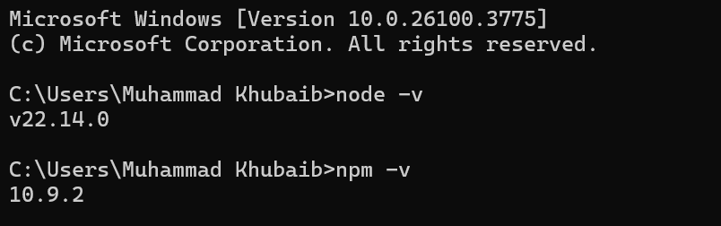

Step 2: Create Project Folder

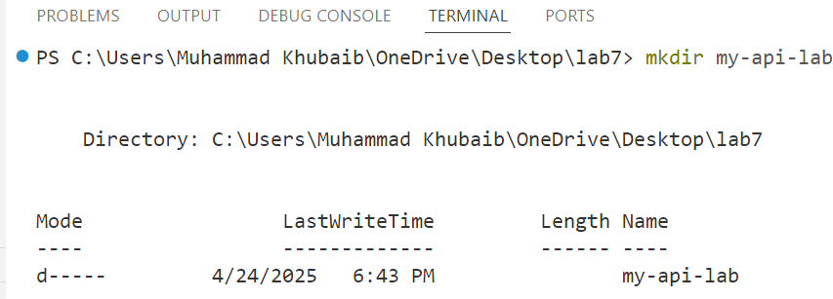

**Step 2: Initialize Node Project**



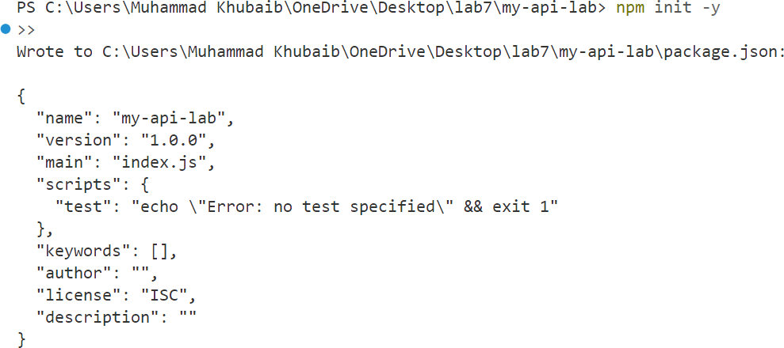

* It will create package.json.

**Step 3: Install Express**

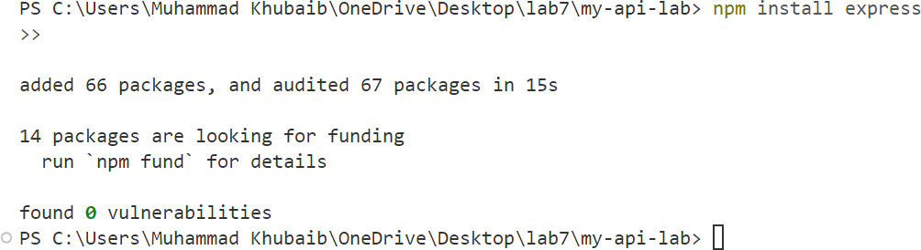

**Step 4: Create Folder and Files.**

* 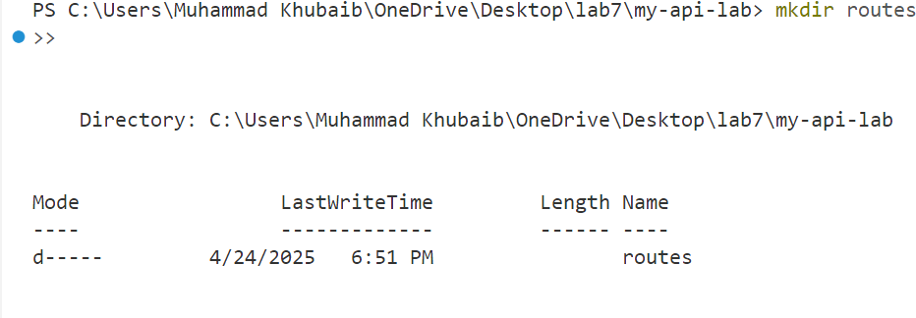**Create Folder for Routes.**



* 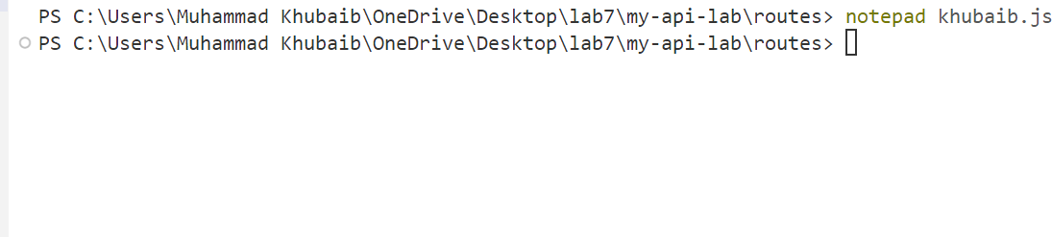**Create khubaib.js File in Router Folder.**
* **Create server.js Go back to main folder and add server.js**



**Step 5: Add "type": "module" to package.json.**

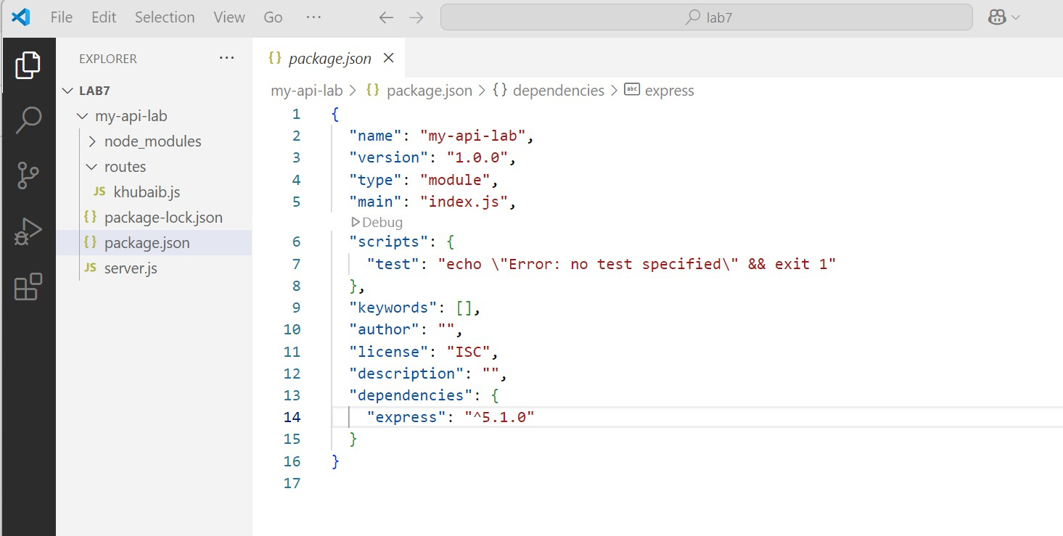



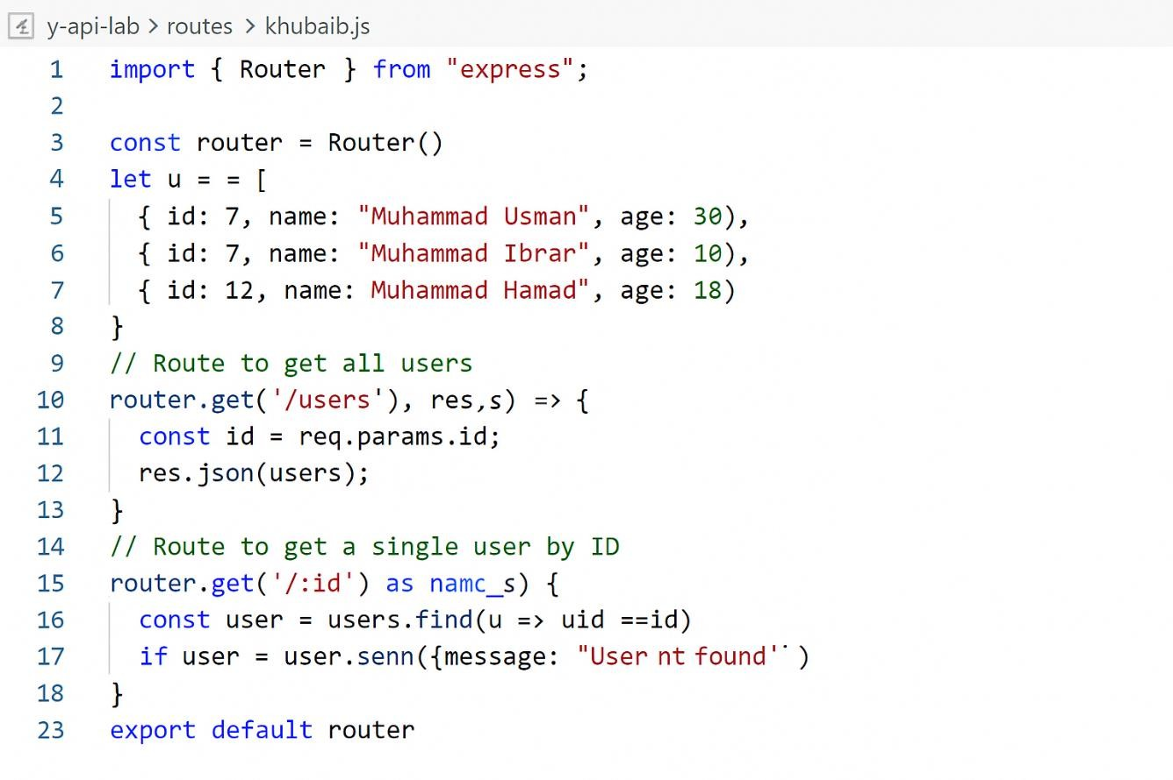**Step6: Write Code Now**

**Server.js:**

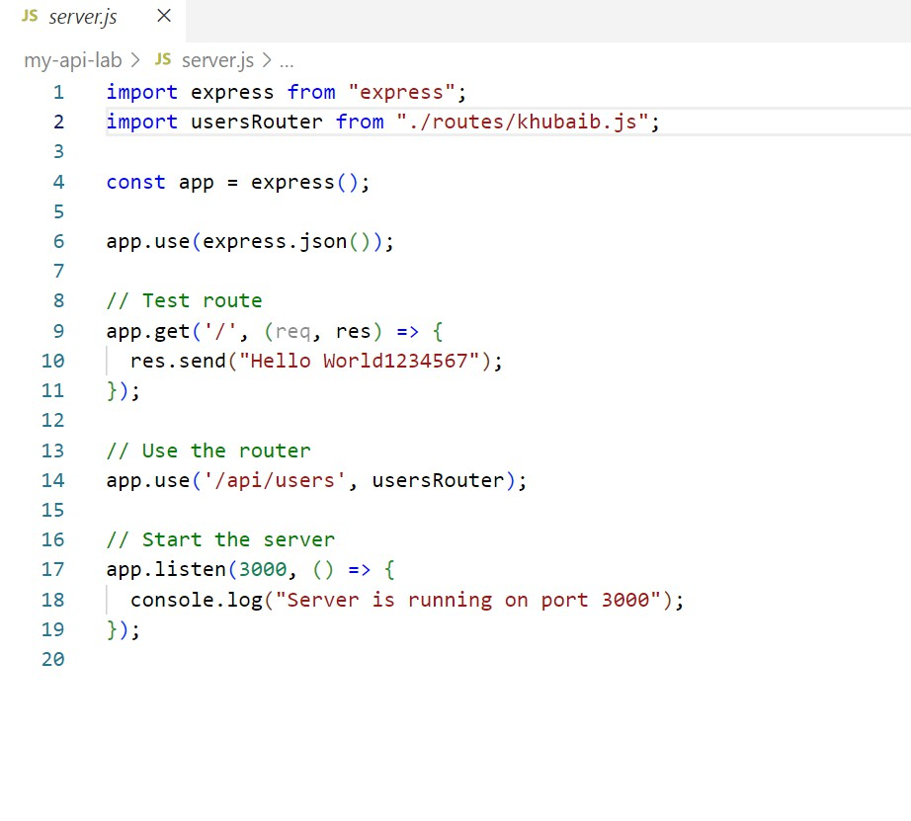

**Step 7: Run Your Project:**

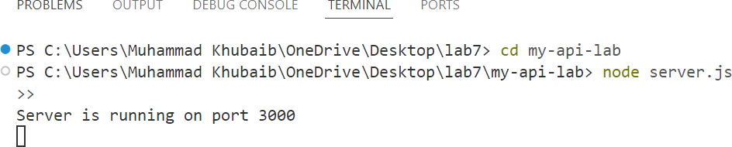

**All Users Check:**

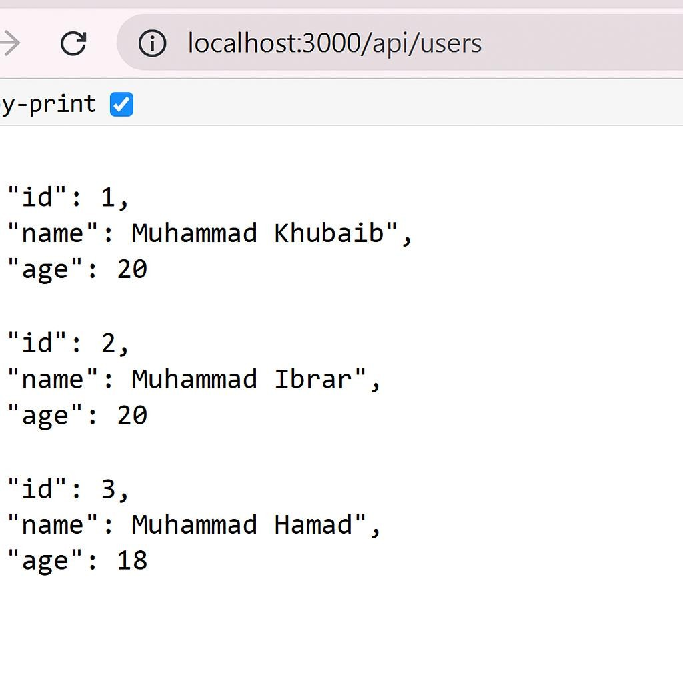

**BYID CHECK:**

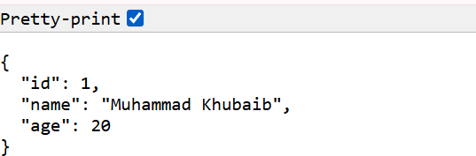



#### GENERALIZED LAB RUBRICS

**Domain**

**Component**

**Above**

**with Taxonomy 4)**

**Meeting**

**Expectation 3)**

**Approaching**

**Expectation 2)**

**Below**

**Expectation 1)**

**Weight /**

**Expectation**

**Used 00**

**Score**

**Optional) 1–4)**

**Psychomotor Building**

**Hardware)**

**s able to build a given setup neatly nd timely using orrect hardware omponents and / or can reorganize / dapt to new / pecial equirements**

**s able to ssemble a given etup using**

**orrect hardware**

**s only able to s not able to opy a given ssemble a**

**etup using given setup**

☐

**minor revisions**

**omponents after omponents hardware**

**orrect hardware using correct**

**omponents**

**Cognitive**

**Recording**

**Measurements**

**s unable to**

**ecord accurate**

☐

**s only able to ecord accurate**

**s able to record ccurate**

**s able to record ccurate**

**Hardware / Software)**

**measurements all he time**

**measurements most of the time**

**measurements on some occasions**

**measurements**

**s able to formulate**

**develop theories in s able to evaluate s partially able to**

**nvestigation Software)**

**ddition to valuating concluding orrectly about nvestigation parameters by ssessing data**

**conclude orrectly about nvestigation parameters by ssessing data**

**valuate conclude orrectly about nvestigation parameters by ssessing data**

**s unable to**

**omprehend** ☐

**nvestigation**

**parameters**

**Design /**

**s able to design /**

**s able to design / s able to partially s unable to**

**Development of Solution Hardware / Software)**

**develop the olution of a given problem and add eatures to it**

**develop the olution of a given problem**

**design / develop he solution of a given problem**

**partially design / develop the** ☐ **olution of a**

**given problem**

**Software Usage**

**s adept in the use**

**f software tool and**

**s able to use the**

**oftware tool ffectively by**

**s able to use the**

**oftware tool but s unable to use**

**annot access all** ☐

**Software)**

**an access**

**dvanced features**

**ccessing all the equired features**

**he required eatures**

**he software tool**

**Programming Language**

**s able to efficiently omplete a given ask using**

**dvanced programming**

**anguage**

**s able to omplete a given ask using equired**

**programming**

**s able to partially s unable to**

**omplete a given partially** ☐

**Software)**

**onstructs / methods / ommands and/or dd features to the original task**

**anguage onstructs / methods / ommands**

**ask**

**omplete a**

**given task**



#### GENERALIZED LAB RUBRICS

**Component Above**

**Domain with**

**axonomy**

**Expectation 4)**

**Meeting Expectation 3)**

**Approaching Expectation 2)**

**Below Expectation 1)**

**Weight / Used 00**

**Optional)**

**Score 1–4)**

**Safety nstructions PLO6)**

**Assesses and omplies with all EHS instructions while in lab**

**Assesses and omplies with most**

**Assesses and omplies with some**

**Assesses and**

**EHS instructions while EHS instructions while EHS instructions in**

**omplies with few** ☐

**n lab**

**n lab**

**ab**

**Affective**

**Professional Ethics PLO8)**

**Exhibits exemplary rofessional ethics**

**while writing lab eports and dealing with fellow students, ab staff and**

**Exhibits professional Makes an effort to thics while writing xhibit professional ab reports and thics while writing**

**ealing with fellow ab reports and**

**Does not exhibit rofessional ethics**

**while writing lab eports and dealing with fellow**

**tudents, lab staff**

☐

**tudents, lab staff and tudents, lab staff and**

**ealing with fellow**

**nstructor all the time nstructor all the time nstructor all the time**

**nd instructor all he time**

**Consistently shows ull preparation by**

**ompleting all**

**Consistently shows ull preparation by**

**Shows some reparation which is**

**Shows very little or**

**Contribution**

**greed tasks and**

**ompleting all agreed mostly at superficial**

**o preparation in**

**PLO9)**

**rovides additional esources for the**

**asks and work equires little or no**

**evel in completing a ompleting a task** ☐

**ask and work requires nd work quality is**

**Attitude PLO9)**

**roup and work uality is excellent**

**nternalized positive ehavior and ncourages and**

**elps other team**

**evisions**

**Consistent positive ehavior most of the ime towards other**

**much revisions and**

**diting**

**Neither helpful nor amaging and shows isinterest in the**

**oor**

**Discouraging**

**ehavior towards** ☐

**ther team**

**members**

**eam members**

**erformance of others members**

**Report on all relevantReport on all relevant Report on all relevant**

**ections related to**

**ections related to the**

**ections related to the**

**he lab tasks is ab tasks is completed ab tasks is completed Report on all**

**Report**

**ompleted**

**ut few deficiencies**

**ut many deficiencies**

**elevant sections**

**Writing**

**ccurately, meeting**

**re present in terms of re present in terms of elated to the lab** ☐

**PLO10)**

**he requirements, in**

**ccuracy / meeting the**

**ccuracy / meeting the asks is not**

**ab Task**

**rescribed time and with good language kills**

**Manages tasks well**

**equirements / rescribed time / good anguage skills**

**Manages tasks within**

**equirements / rescribed time / good anguage skills**

**Manages tasks in an**

**ompleted**

**Does not manage**

**Management within given**

**iven timeframe**

**xtended timeframe**

**asks even in** ☐

**PLO11)**



**imeframe**

**xtended imeframes**



### LAB 08

**Create a CRUD operation using Node.js and Express.js**

**Web Development**

## SOLUTION

**Router:**

import express from 'express'; import mongoose from 'mongoose';

import Recipe from '../models/recipe.js';

const router = express.Router();

// Create a new recipe router.post('/', async (req, res) => {

try {

const recipe = new Recipe(req.body); await recipe.save(); res.status(201).send(recipe);

} catch (error) { res.status(400).send(error);

}

});

// Read all recipes

router.get('/', async (req, res) => { try {

const recipes = await Recipe.find(); res.status(200).send(recipes);

} catch (error) { res.status(500).send(error);

}

});

router.get('/page/:pageNumber', async (req, res) => { const page = parseInt(req.params.pageNumber, 10); const limit = 5; // Number of recipes per page const skip = (page - 1) * limit;

try {

const recipes = await Recipe.find().skip(skip).limit(limit);



res.status(200).send(recipes);

} catch (error) { res.status(500).send(error);

}

});

router.get('/last-page', async (req, res) => { const limit = 5; // Number of recipes per page

try {

const count = await Recipe.countDocuments(); const lastPage = Math.ceil(count / limit); res.status(200).send({ lastPage });

} catch (error) { res.status(500).send(error);

}

});

router.get('/:id', async (req, res) => { try {

const recipe = await Recipe.findById(req.params.id); if (!recipe) {

return res.status(404).send();

}

res.status(200).send(recipe);

} catch (error) { res.status(500).send(error);

}

});

// Update a recipe by ID router.put('/:id', async (req, res) => {

try {

const recipe = await Recipe.findByIdAndUpdate(req.params.id, req.body, { new: true, runValidators: true });

if (!recipe) {

return res.status(404).send();

}

res.status(200).send(recipe);

} catch (error) { res.status(400).send(error);

}}

);

// Delete a recipe by ID router.delete('/:id', async (req, res) => {

try {



const recipe = await Recipe.findByIdAndDelete(req.params.id); if (!recipe) {

return res.status(404).send();

}

res.status(200).send(recipe);

} catch (error) { res.status(500).send(error);

}

});

export default router;

## Recipes.js:

import mongoose from 'mongoose'; const Schema = mongoose.Schema; const recipeSchema = new Schema({

title: {

type: String, required: true

},

ingredients: { type: String, required: true

},

instructions: { type: String, required: true

},

createdAt: {

type: Date, default: Date.now

}

});

const Recipe = mongoose.model('Recipe', recipeSchema); export default Recipe;



**GENERALIZED LAB RUBRICS**

|  |  |  |  |  |  |  |  |  |
| --- | --- | --- | --- | --- | --- | --- | --- | --- |
| **Domain** | **Component with Taxonomy** | **Above Expectation (4)** | **Meeting Expectation (3)** | **Approaching Expectation (2)** | **Below Expectation (1)** | **Used** | **Weight / 100**  **(Optional)** | **Score (1–4)** |
| **Psychomotor** | **Building (**Hardware) | Is able to build a given setup neatly and timely using correct hardware components and / or can reorganize / adapt to new / special requirements | Is able to assemble a given setup using correct hardware components after minor revisions | Is only able to copy a given setup using correct hardware components | Is not able to assemble a given setup using correct hardware components | ☐ |  |  |
| **Cognitive** | **Recording Measurements** (Hardware / Software) | Is able to record accurate measurements all the time | Is able to record accurate measurements most of the time | Is only able to record accurate measurements on some occasions | Is unable to record accurate measurements | ☐ |  |  |
| **Investigation**  (Software) | Is able to formulate  /develop theories in addition to evaluating  /concluding correctly about investigation parameters by assessing data | Is able to evaluate  /conclude correctly about investigation parameters by assessing data | Is partially able to evaluate  /conclude correctly about investigation parameters by assessing data | Is unable to comprehend investigation parameters | ☐ |  |  |
| **Design / Development of Solution** (Hardware / Software) | Is able to design / develop the solution of a given problem and add features to it | Is able to design / develop the solution of a given problem | Is able to partially design / develop the solution of a given problem | Is unable to partially design / develop the solution of a given problem | ☐ |  |  |
| **Software Usage** (Software) | Is adept in the use of software tool and can access advanced features | Is able to use the software tool effectively by accessing all the required features | Is able to use the software tool but cannot access all the required features | Is unable to use the software tool | ☐ |  |  |
| **Programming Language** (Software) | Is able to efficiently complete a given task using advanced programming language constructs  / methods / commands and/or add features to the original task | Is able to complete a given task using required programming language constructs / methods / commands | Is able to partially complete a given task | Is unable to partially complete a given task | ☐ |  |  |



#### GENERALIZED LAB RUBRICS

|  |  |  |  |  |  |  |  |  |
| --- | --- | --- | --- | --- | --- | --- | --- | --- |
| **Domain** | **Component with Taxonomy** | **Above Expectation (4)** | **Meeting Expectation (3)** | **Approaching Expectation (2)** | **Below Expectation (1)** | **Used** | **Weight / 100**  **(Optional)** | **Score (1–4)** |
| **Affective** | **Safety Instructions (PLO6)** | Assesses and complies with all EHS instructions while in lab | Assesses and complies with most EHS instructions while in lab | Assesses and complies with some EHS instructions while in lab | Assesses and complies with few EHS instructions in lab | ☐ |  |  |
| **Professional Ethics (PLO8)** | Exhibits exemplary professional ethics while writing lab reports and dealing with fellow students, lab staff and instructor all the time | Exhibits professional ethics while writing lab reports and dealing with fellow students, lab staff and instructor all the time | Makes an effort to exhibit professional ethics while writing lab reports and dealing with fellow students, lab staff and instructor all the time | Does not exhibit professional ethics while writing lab reports and dealing with fellow students, lab staff and instructor all the time | ☐ |  |  |
| **Contribution (PLO9)** | Consistently shows full preparation by completing all agreed tasks and provides additional resources for the group and work quality is excellent | Consistently shows full preparation by completing all agreed tasks and work requires little or no revisions | Shows some preparation which is mostly at superficial level in completing a task and work requires much revisions and editing | Shows very little or no preparation in completing a task and work quality is poor | ☐ |  |  |
| **Attitude (PLO9)** | Internalized positive behavior and encourages and helps other team members | Consistent positive behavior most of the time towards other team members | Neither helpful nor damaging and shows disinterest in the performance of others | Discouraging behavior towards other team members | ☐ |  |  |
| **Report Writing (PLO10)** | Report on all relevant sections related to the lab tasks is completed accurately, meeting the requirements, in prescribed time and with good language skills | Report on all relevant sections related to the lab tasks is completed but few deficiencies are present in terms of accuracy / meeting the requirements / prescribed time / good language skills | Report on all relevant sections related to the lab tasks is completed but many deficiencies are present in terms of accuracy / meeting the requirements / prescribed time / good language skills | Report on all relevant sections related to the lab tasks is not completed | ☐ |  |  |
| **Lab Task Management (PLO11)** | Manages tasks well within given timeframe | Manages tasks within given timeframe | Manages tasks in an extended timeframe | Does not manage tasks even in extended timeframes | ☐ |  |  |

**LAB 09**

**Introduction to Mongo db.**

**Create an account in Mongo db and attached it to your website.**

**Web Development:**

For Using MONGODB firstly I creted account on there website: [https://cloud.mongodb.com](https://cloud.mongodb.com/)

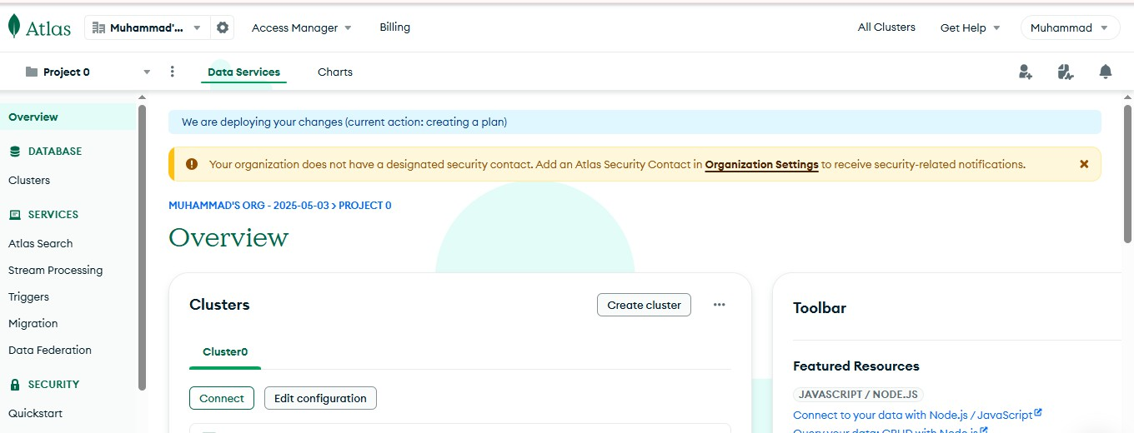



Now I will create a cluster and add the connection string into my code in the .env file of node.js

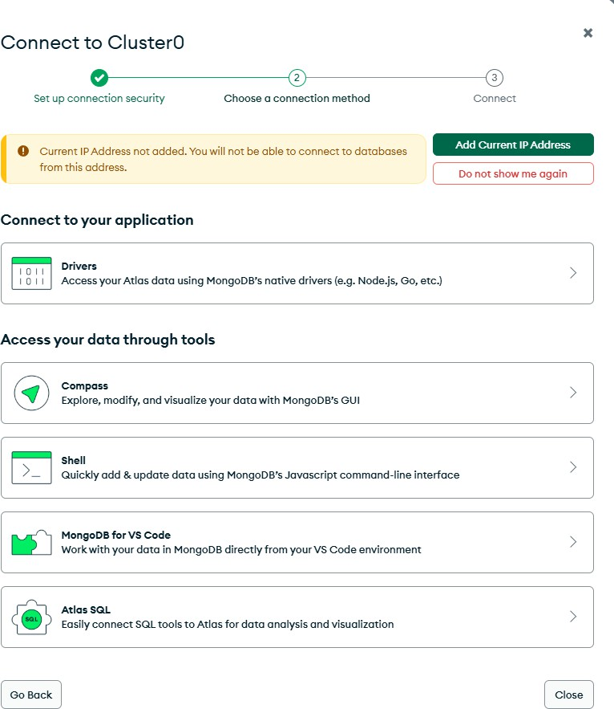



We also have to add my ip address in the account so we can access it later.

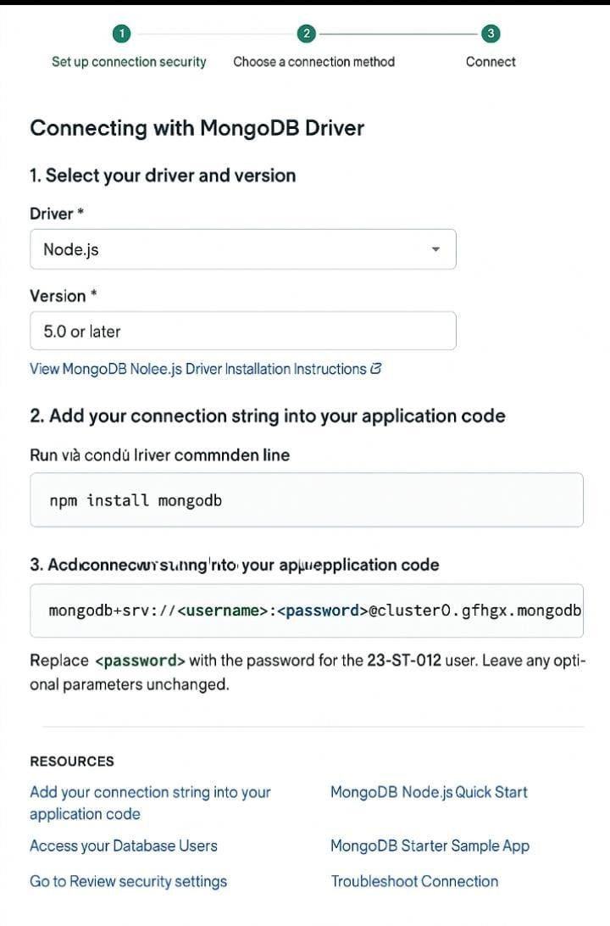



This is the connection string I have to add to my project to connect to mongoDB.

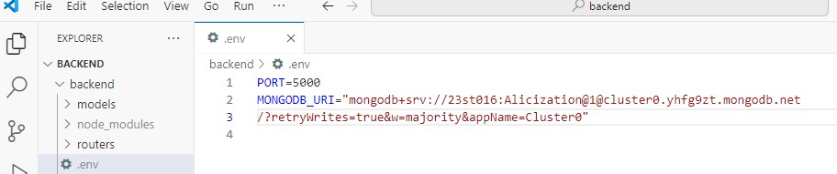

Note that it is the same file I have used in the previous lab

**GENERALIZED LAB RUBRICS**

|  |  |  |  |  |  |  |  |  |
| --- | --- | --- | --- | --- | --- | --- | --- | --- |
| **Domain** | **Component with Taxonomy** | **Above Expectation (4)** | **Meeting Expectation (3)** | **Approaching Expectation (2)** | **Below Expectation (1)** | **Used** | **Weight / 100**  **(Optional)** | **Score (1–4)** |
| **Psychomotor** | **Building (**Hardware) | Is able to build a given setup neatly and timely using correct hardware components and / or can reorganize / adapt to new / special requirements | Is able to assemble a given setup using correct hardware components after minor revisions | Is only able to copy a given setup using correct hardware components | Is not able to assemble a given setup using correct hardware components | ☐ |  |  |
| **Cognitive** | **Recording Measurements** (Hardware / Software) | Is able to record accurate measurements all the time | Is able to record accurate measurements most of the time | Is only able to record accurate measurements on some occasions | Is unable to record accurate measurements | ☐ |  |  |
| **Investigation**  (Software) | Is able to formulate  /develop theories in addition to evaluating  /concluding correctly about investigation parameters by assessing data | Is able to evaluate  /conclude correctly about investigation parameters by assessing data | Is partially able to evaluate  /conclude correctly about investigation parameters by assessing data | Is unable to comprehend investigation parameters | ☐ |  |  |
| **Design / Development of Solution** (Hardware / Software) | Is able to design / develop the solution of a given problem and add features to it | Is able to design / develop the solution of a given problem | Is able to partially design / develop the solution of a given problem | Is unable to partially design  / develop the solution of a given problem | ☐ |  |  |
| **Software Usage** (Software) | Is adept in the use of software tool and can access advanced features | Is able to use the software tool effectively by accessing all the required features | Is able to use the software tool but cannot access all the required features | Is unable to use the software tool | ☐ |  |  |
| **Programming Language** (Software) | Is able to efficiently complete a given task using advanced programming language constructs  / methods / commands and/or add features to the original task | Is able to complete a given task using required programming language constructs / methods / commands | Is able to partially complete a given task | Is unable to partially complete a given task | ☐ |  |  |



**GENERALIZED LAB RUBRICS**

|  |  |  |  |  |  |  |  |  |
| --- | --- | --- | --- | --- | --- | --- | --- | --- |
| **Domain** | **Component with Taxonomy** | **Above Expectation (4)** | **Meeting Expectation (3)** | **Approaching Expectation (2)** | **Below Expectation (1)** | **Used** | **Weight / 100**  **(Optional)** | **Score (1–4)** |
| **Affective** | **Safety Instructions (PLO6)** | Assesses and complies with all EHS instructions while in lab | Assesses and complies with most EHS instructions while in lab | Assesses and complies with some EHS instructions while in lab | Assesses and complies with few EHS instructions in lab | ☐ |  |  |
| **Professional Ethics (PLO8)** | Exhibits exemplary professional ethics while writing lab reports and dealing with fellow students, lab staff and instructor all the time | Exhibits professional ethics while writing lab reports and dealing with fellow students, lab staff and instructor all the time | Makes an effort to exhibit professional ethics while writing lab reports and dealing with fellow students, lab staff and instructor all the time | Does not exhibit professional ethics while writing lab reports and dealing with fellow students, lab staff and instructor all the time | ☐ |  |  |
| **Contribution (PLO9)** | Consistently shows full preparation by completing all agreed tasks and provides additional resources for the group and work quality is excellent | Consistently shows full preparation by completing all agreed tasks and work requires little or no revisions | Shows some preparation which is mostly at superficial level in completing a task and work requires much revisions and editing | Shows very little or no preparation in completing a task and work quality is poor | ☐ |  |  |
| **Attitude (PLO9)** | Internalized positive behavior and encourages and helps other team members | Consistent positive behavior most of the time towards other team members | Neither helpful nor damaging and shows disinterest in the performance of others | Discouraging behavior towards other team members | ☐ |  |  |
| **Report Writing (PLO10)** | Report on all relevant sections related to the lab tasks is completed accurately, meeting the requirements, in prescribed time and with good language skills | Report on all relevant sections related to the lab tasks is completed but few deficiencies are present in terms of accuracy / meeting the requirements / prescribed time / good language skills | Report on all relevant sections related to the lab tasks is completed but many deficiencies are present in terms of accuracy / meeting the requirements / prescribed time / good language skills | Report on all relevant sections related to the lab tasks is not completed | ☐ |  |  |
| **Lab Task Management (PLO11)** | Manages tasks well within given timeframe | Manages tasks within given timeframe | Manages tasks in an extended timeframe | Does not manage tasks even in extended | ☐ |  |  |

|  |  |  |  |  |  |  |  |  |
| --- | --- | --- | --- | --- | --- | --- | --- | --- |
|  |  |  |  |  | timeframes |  |  |  |



### LAB 10

**Introduction to React.js**

**Convert your Lab 2 website into React.js**

**Web Development**

I have converted the Lab2 in react.

CODE of **index.jsx**:

import React from ‘react’;

import ‘./index.css’; // Assuming you have the same stylesheet

const App = () => { return (

<div>

<meta charset=”UTF-8” />

<meta name=”viewport” content=”width=device-width, initial-scale=1.0”

/>

<title>Document</title>

<a href=”index.html”>Home</a>

<a href=”contact.html”>Contact Us</a>

<a href=”gallery.html”>Gallery</a>

<center>

<h1>Welcome to Hanad’s Website</h1>

<h2>About Us</h2>

<h3>Our Mission</h3>

<h4>Our Vision</h4>

<h4>Team</h4>

<h4>Contact Information</h4>

</center>

<p>

Our website dedicated to providing high-quality content and services to our users. We save to meet your needs and exceed your expectations.

Thanks you for visiting, we appreciate your support and look forward to serving you better.

</p>

<ul>

<li>Top Feature</li>

<li>Comprehensive Resource</li>



<li>User-Friendly Design</li>

<li>Reliable Support</li>

</ul>

<ul>

<li>Our Service</li>

<li>Consulting</li>

<li>Training</li>

<li>Product Development</li>

<li>Customer Support</li>

</ul>

<table border=”1”>

<tr>

<td><b>Name</b></td>

<td>Muhammad Hanad</td>

<td>Umair</td>

<td>Sainan</td>

</tr>

<tr>

<td><b>Role</b></td>

<td>CEO</td>

<td>Worker</td>

<td>Worker</td>

</tr>

<tr>

<td><b>E-mail</b></td>

[<td>hanadmuhammed395@gmail.com</](mailto:hanadmuhammed395@gmail.com)td>

[<td>example@gmail.com</td>](mailto:example@gmail.com)

[<td>umair@gmail.com](mailto:umair@gmail.com)</td>

</tr>

</table>

</div>

);

};

export default App;

CODE of **Home.jsx**

import styled, { createGlobalStyle } from ‘styled-components’;

// Global styles

export const GlobalStyle = createGlobalStyle` body {



margin: 0;

padding: 0;

font-family: ‘Poppins’, sans-serif;

background: linear-gradient(135deg, #ffffff, #e0e7ff); color: #333;

line-height: 1.6;

}

`;

// Navigation component

export const Navigation = styled.nav`

background: linear-gradient(90deg, #000000, #000000); padding: 15px;

text-align: center;

box-shadow: 0.4px 8px rgba(0, 0, 0, 0.1);

a {

text-decoration: none; color: white;

margin: 0.15px; font-size: 1.2rem; font-weight: bold;

text-transform: uppercase; padding: 8px 12px;

border-radius: 5px;

transition: background-color 0.3s, transform 0.3s;

&:hover {

background-color: rgba(255, 255, 255, 0.2); transform: scale(1.1);

}

}

`;

// Headings component

export const Heading = styled.h1` color: #000000;

text-transform: uppercase; margin: 20px 0;

text-align: center; font-weight: bold; font-size: 3rem;

border-bottom: 4px solid #020202; display: inline-block;

padding-bottom: 10px;



/* Shared styles for h2, h3, h4 */ &&& {

font-size: 1.8rem; margin-top: 15px; letter-spacing: 1px; border-bottom: none;

}

`;

// Paragraph component

export const Paragraph = styled.p` width: 90%;

max-width: 800px; margin: 20px auto; font-size: 1.2rem; padding: 15px; background: #ffffff;

border-left: 6px solid #000000; border-radius: 10px;

box-shadow: 0 5px 15px rgba(0, 0, 0, 0.2);

line-height: 1.8;

`;

CODE of **Contact.jsx:**

import React, { useState } from ‘react’; import { Link } from ‘react-router-dom’;

const Contact = () => {

const [formData, setFormData] = useState({ fullName: ‘’,

password: ‘’,

email: ‘’, maritalStatus: ‘’, subjects: [], feedback: ‘’

});

const handleInputChange = (e) => {

const { name, value, type, checked } = e.target;

if (type === ‘checkbox’) { setFormData(prev => ({

…prev,

subjects: checked

? […prev.subjects, value]

: prev.subjects.filter(subject => subject !== value)



}));

} else { setFormData(prev => ({

…prev, [name]: value

}));

}

};

const handleSubmit = (e) => { e.preventDefault();

// Handle form submission here console.log(formData);

};

return (

<div className=”contact-container”>

<nav>

<Link to=”/”>Home</Link>

<Link to=”/contact”>Contact Us</Link>

<Link to=”/gallery”>Gallery</Link>

</nav>

<h1>Contact Us</h1>

<form onSubmit={handleSubmit}>

<div className=”form-group”>

<label>

Full Name:

<input

type=”text” name=”fullName” placeholder=”Username” value={formData.fullName}

onChange={handleInputChange}

/>

</label>

</div>

<div className=”form-group”>

<label> Password:

<input

type=”password” name=”password” placeholder=”Password” value={formData.password}

onChange={handleInputChange}



/>

</label>

</div>

<div className=”form-group”>

<label> E-mail:

<input

type=”email” name=”email” placeholder=”Email” value={formData.email}

onChange={handleInputChange}

/>

</label>

</div>

<div className=”form-group”>

<fieldset>

<legend>Marital Status:</legend>

<label>

<input

type=”radio” name=”maritalStatus” value=”married”

checked={formData.maritalStatus === ‘married’} onChange={handleInputChange}

/> Married

</label>

<label>

<input

type=”radio” name=”maritalStatus” value=”single”

checked={formData.maritalStatus === ‘single’} onChange={handleInputChange}

/> Single

</label>

</fieldset>

</div>

<div className=”form-group”>

<fieldset>

<legend>Subjects:</legend>

{[‘math’, ‘physic’, ‘chemistry’, ‘urdu’].map(subject => (



<label key={subject}>

<input

type=”checkbox” name=”subjects” value={subject}

checked={formData.subjects.includes(subject)} onChange={handleInputChange}

/>

{subject.charAt(0).toUpperCase() + subject.slice(1)}

</label>

))}

</fieldset>

</div>

<div className=”form-group”>

<label> Feedback:

<textarea name=”feedback”

value={formData.feedback} onChange={handleInputChange} placeholder=”Enter your feedback here…”

/>

</label>

</div>

<button type=”submit”>Submit</button>

</form>

</div>

);

};

export default Contact;



Output:

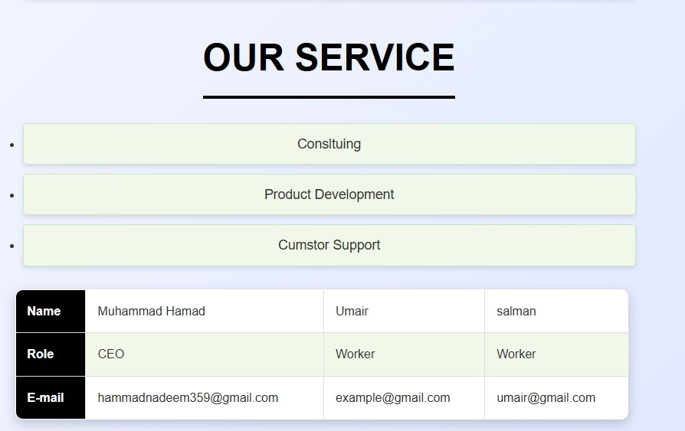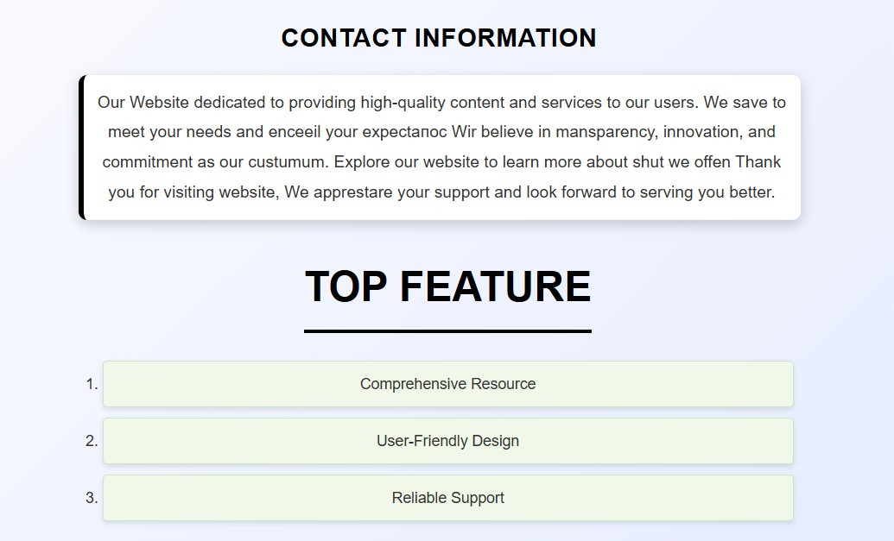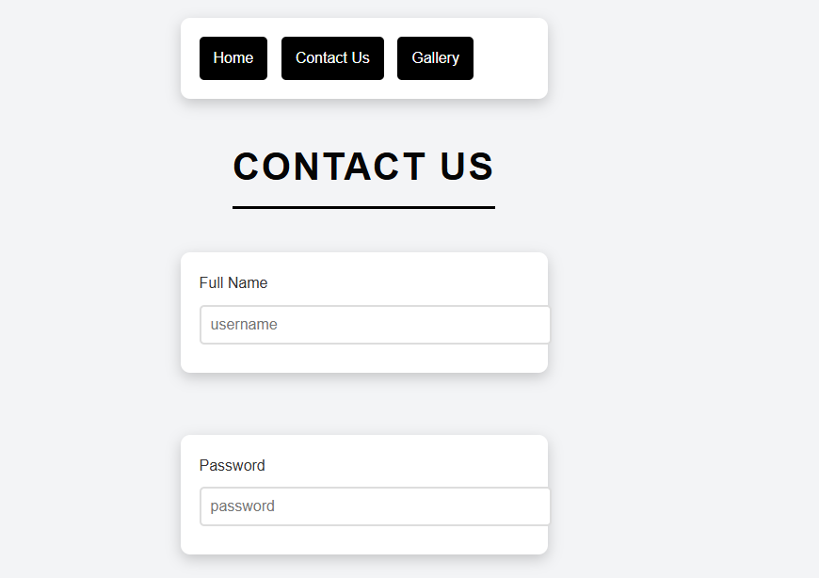



#### GENERALIZED LAB RUBRICS

|  |  |  |  |  |  |  |  |  |
| --- | --- | --- | --- | --- | --- | --- | --- | --- |
| **Domain** | **Component with Taxonomy** | **Above Expectation (4)** | **Meeting Expectation (3)** | **Approaching Expectation (2)** | **Below Expectation (1)** | **Used** | **Weight / 100**  **(Optional)** | **Score (1–4)** |
| **Psychomotor** | **Building (**Hardware) | Is able to build a given setup neatly and timely using correct hardware components and / or can reorganize / adapt to new / special requirements | Is able to assemble a given setup using correct hardware components after minor revisions | Is only able to copy a given setup using correct hardware components | Is not able to assemble a given setup using correct hardware components | ☐ |  |  |
| **Cognitive** | **Recording Measurements** (Hardware / Software) | Is able to record accurate measurements all the time | Is able to record accurate measurements most of the time | Is only able to record accurate measurements on some occasions | Is unable to record accurate measurements | ☐ |  |  |
| **Investigation**  (Software) | Is able to formulate  /develop theories in addition to evaluating  /concluding correctly about investigation parameters by assessing data | Is able to evaluate  /conclude correctly about investigation parameters by assessing data | Is partially able to evaluate  /conclude correctly about investigation parameters by assessing data | Is unable to comprehend investigation parameters | ☐ |  |  |
| **Design / Development of Solution** (Hardware / Software) | Is able to design / develop the solution of a given problem and add features to it | Is able to design / develop the solution of a given problem | Is able to partially design / develop the solution of a given problem | Is unable to partially design / develop the solution of a given problem | ☐ |  |  |
| **Software Usage** (Software) | Is adept in the use of software tool and can access advanced features | Is able to use the software tool effectively by accessing all the required features | Is able to use the software tool but cannot access all the required features | Is unable to use the software tool | ☐ |  |  |
| **Programming Language** (Software) | Is able to efficiently complete a given task using advanced programming language constructs  / methods / commands and/or add features to the original task | Is able to complete a given task using required programming language constructs / methods / commands | Is able to partially complete a given task | Is unable to partially complete a given task | ☐ |  |  |



**GENERALIZED LAB RUBRICS**

|  |  |  |  |  |  |  |  |  |
| --- | --- | --- | --- | --- | --- | --- | --- | --- |
| **Domain** | **Component with Taxonomy** | **Above Expectation (4)** | **Meeting Expectation (3)** | **Approaching Expectation (2)** | **Below Expectation (1)** | **Used** | **Weight / 100**  **(Optional)** | **Score (1–4)** |
| **Affective** | **Safety Instructions (PLO6)** | Assesses and complies with all EHS instructions while in lab | Assesses and complies with most EHS instructions while in lab | Assesses and complies with some EHS instructions while in lab | Assesses and complies with few EHS instructions in lab | ☐ |  |  |
| **Professional Ethics (PLO8)** | Exhibits exemplary professional ethics while writing lab reports and dealing with fellow students, lab staff and instructor all the time | Exhibits professional ethics while writing lab reports and dealing with fellow students, lab staff and instructor all the time | Makes an effort to exhibit professional ethics while writing lab reports and dealing with fellow students, lab staff and instructor all the time | Does not exhibit professional ethics while writing lab reports and dealing with fellow students, lab staff and instructor all the time | ☐ |  |  |
| **Contribution (PLO9)** | Consistently shows full preparation by completing all agreed tasks and provides additional resources for the group and work quality is excellent | Consistently shows full preparation by completing all agreed tasks and work requires little or no revisions | Shows some preparation which is mostly at superficial level in completing a task and work requires much revisions and editing | Shows very little or no preparation in completing a task and work quality is poor | ☐ |  |  |
| **Attitude (PLO9)** | Internalized positive behavior and encourages and helps other team members | Consistent positive behavior most of the time towards other team members | Neither helpful nor damaging and shows disinterest in the performance of others | Discouraging behavior towards other team members | ☐ |  |  |
| **Report Writing (PLO10)** | Report on all relevant sections related to the lab tasks is completed accurately, meeting the requirements, in prescribed time and with good language skills | Report on all relevant sections related to the lab tasks is completed but few deficiencies are present in terms of accuracy / meeting the requirements / prescribed time / good language skills | Report on all relevant sections related to the lab tasks is completed but many deficiencies are present in terms of accuracy / meeting the requirements / prescribed time / good language skills | Report on all relevant sections related to the lab tasks is not completed | ☐ |  |  |
| **Lab Task Management (PLO11)** | Manages tasks well within given timeframe | Manages tasks within given timeframe | Manages tasks in an extended timeframe | Does not manage tasks even in extended | ☐ |  |  |

|  |  |  |  |  |  |  |  |  |
| --- | --- | --- | --- | --- | --- | --- | --- | --- |
|  |  |  |  |  | timeframes |  |  |  |



**LAB 11**

**Project:**

**Create a React based frontend website for your previous project you submitted.**

**Web Development**

Solution of lab 11:

For this project I have converted me previous frontend project into react.js app.

This is a big project with long line of codes so I will only add some Code screenshots of the project And output output screenshots also.I will show my whole project code in class during evaluation.

### CODE:

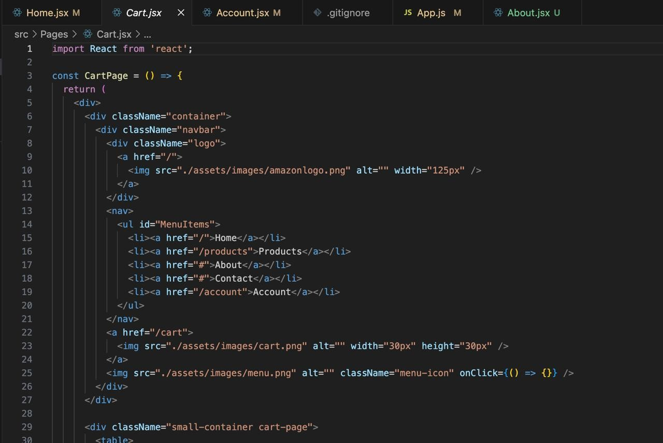



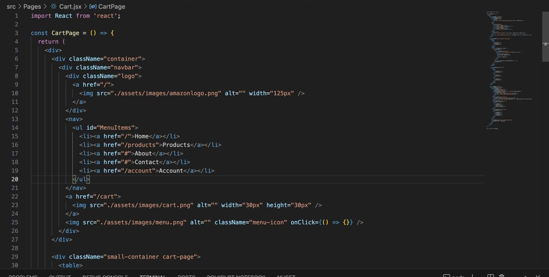

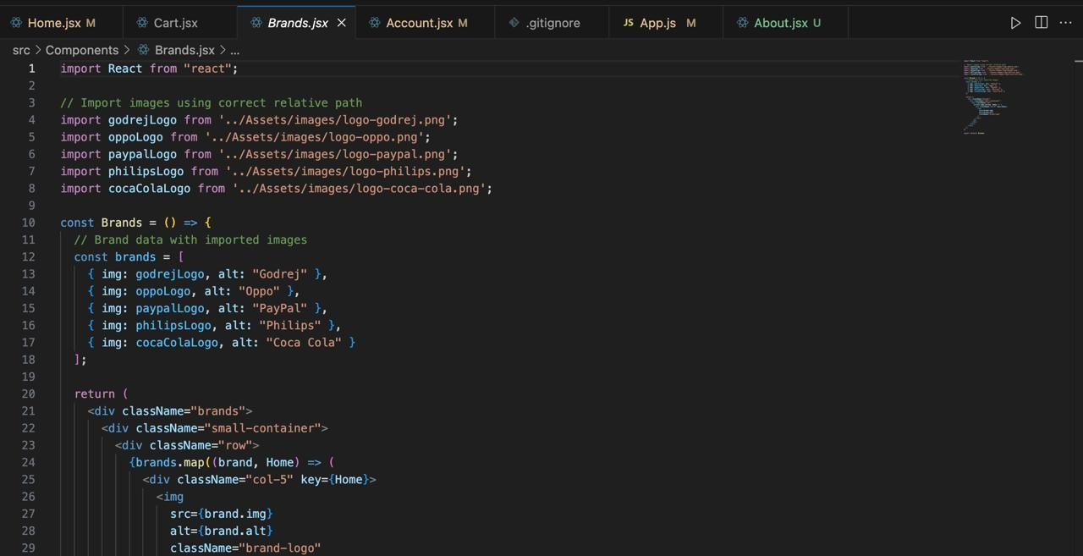



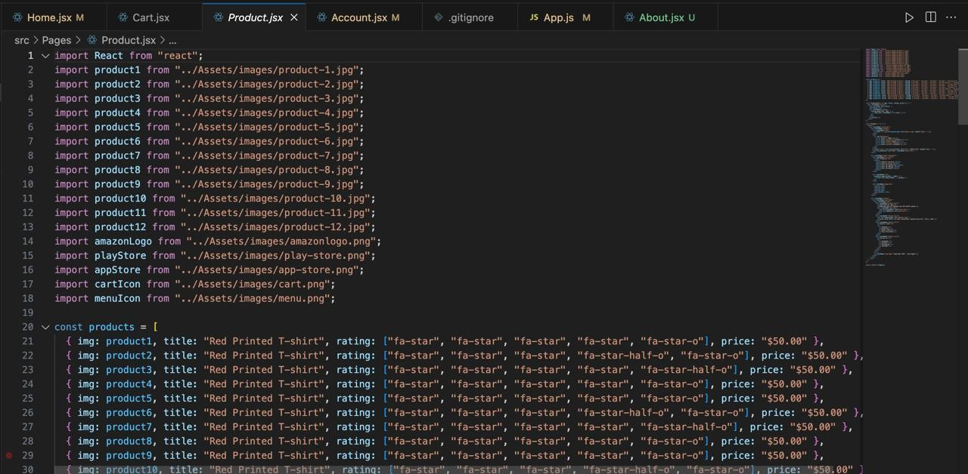

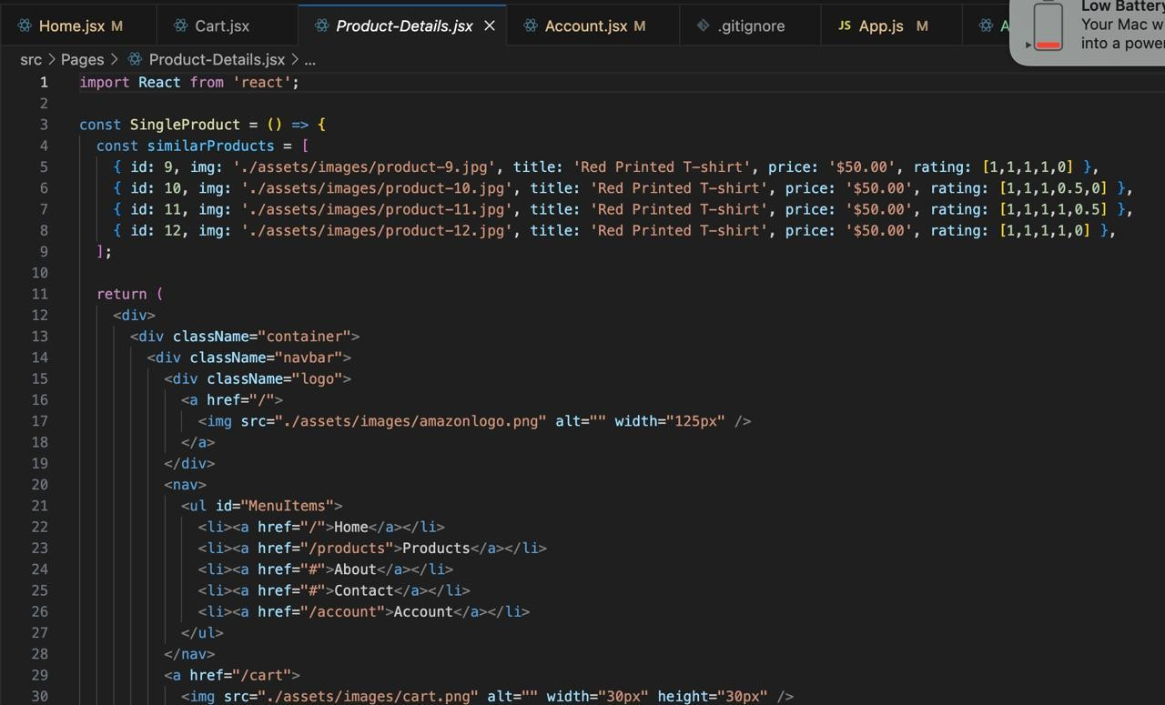



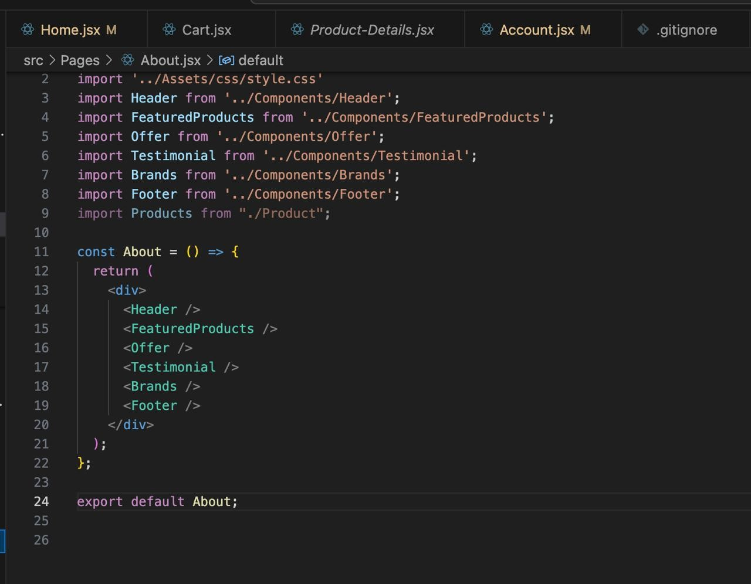



**OUTPUT OF CODE(PROJECT):**





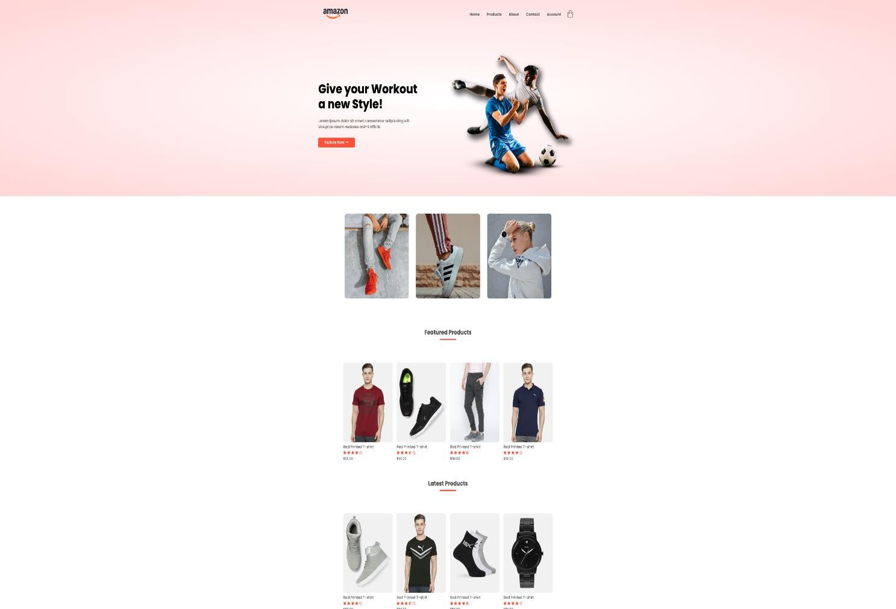

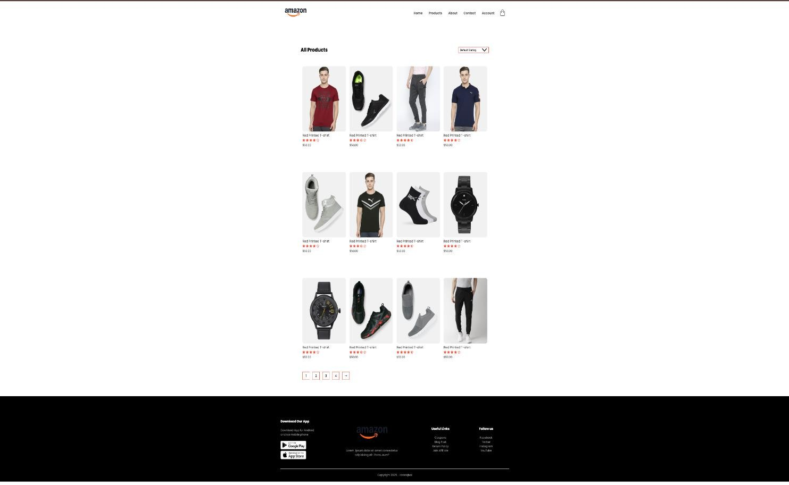



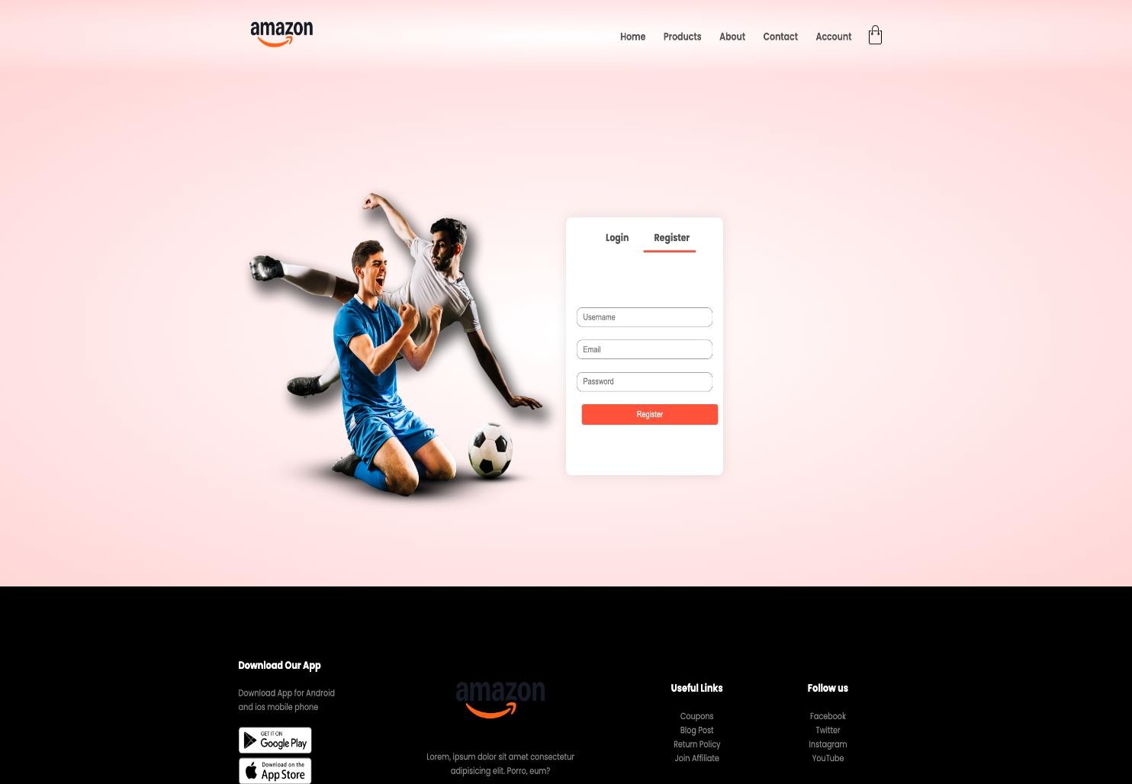



**GENERALIZED LAB RUBRICS**

|  |  |  |  |  |  |  |  |  |
| --- | --- | --- | --- | --- | --- | --- | --- | --- |
| **Domain** | **Component with Taxonomy** | **Above Expectation (4)** | **Meeting Expectation (3)** | **Approaching Expectation (2)** | **Below Expectation (1)** | **Used** | **Weight / 100**  **(Optional)** | **Score (1–4)** |
| **Psychomotor** | **Building (**Hardware) | Is able to build a given setup neatly and timely using correct hardware components and / or can reorganize / adapt to new / special requirements | Is able to assemble a given setup using correct hardware components after minor revisions | Is only able to copy a given setup using correct hardware components | Is not able to assemble a given setup using correct hardware components | ☐ |  |  |
| **Cognitive** | **Recording Measurements** (Hardware / Software) | Is able to record accurate measurements all the time | Is able to record accurate measurements most of the time | Is only able to record accurate measurements on some occasions | Is unable to record accurate measurements | ☐ |  |  |
| **Investigation**  (Software) | Is able to formulate  /develop theories in addition to evaluating  /concluding correctly about investigation parameters by assessing data | Is able to evaluate  /conclude correctly about investigation parameters by assessing data | Is partially able to evaluate  /conclude correctly about investigation parameters by assessing data | Is unable to comprehend investigation parameters | ☐ |  |  |
| **Design / Development of Solution** (Hardware / Software) | Is able to design / develop the solution of a given problem and add features to it | Is able to design / develop the solution of a given problem | Is able to partially design / develop the solution of a given problem | Is unable to partially design / develop the solution of a given problem | ☐ |  |  |
| **Software Usage**  (Software) | Is adept in the use of software tool and can access advanced features | Is able to use the software tool effectively by accessing all the required features | Is able to use the software tool but cannot access all the required features | Is unable to use the software tool | ☐ |  |  |
| **Programming Language** (Software) | Is able to efficiently complete a given task using advanced programming language constructs  / methods / commands and/or add features to the original task | Is able to complete a given task using required programming language constructs / methods / commands | Is able to partially complete a given task | Is unable to partially complete a given task | ☐ |  |  |

**GENERALIZED LAB RUBRICS**



|  |  |  |  |  |  |  |  |  |
| --- | --- | --- | --- | --- | --- | --- | --- | --- |
| **Domain** | **Component with Taxonomy** | **Above Expectation (4)** | **Meeting Expectation (3)** | **Approaching Expectation (2)** | **Below Expectation (1)** | **Used** | **Weight / 100**  **(Optional)** | **Score (1–4)** |
| **Affective** | **Safety Instructions (PLO6)** | Assesses and complies with all EHS instructions while in lab | Assesses and complies with most EHS instructions while in lab | Assesses and complies with some EHS instructions while in lab | Assesses and complies with few EHS instructions in lab | ☐ |  |  |
| **Professional Ethics (PLO8)** | Exhibits exemplary professional ethics while writing lab reports and dealing with fellow students, lab staff and instructor all the time | Exhibits professional ethics while writing lab reports and dealing with fellow students, lab staff and instructor all the time | Makes an effort to exhibit professional ethics while writing lab reports and dealing with fellow students, lab staff and instructor all the time | Does not exhibit professional ethics while writing lab reports and dealing with fellow students, lab staff and instructor all the time | ☐ |  |  |
| **Contribution (PLO9)** | Consistently shows full preparation by completing all agreed tasks and provides additional resources for the group and work quality is excellent | Consistently shows full preparation by completing all agreed tasks and work requires little or no revisions | Shows some preparation which is mostly at superficial level in completing a task and work requires much revisions and editing | Shows very little or no preparation in completing a task and work quality is poor | ☐ |  |  |
| **Attitude (PLO9)** | Internalized positive behavior and encourages and helps other team members | Consistent positive behavior most of the time towards other team members | Neither helpful nor damaging and shows disinterest in the performance of others | Discouraging behavior towards other team members | ☐ |  |  |
| **Report Writing (PLO10)** | Report on all relevant sections related to the lab tasks is completed accurately, meeting the requirements, in prescribed time and with good language skills | Report on all relevant sections related to the lab tasks is completed but few deficiencies are present in terms of accuracy / meeting the requirements / prescribed time / good language skills | Report on all relevant sections related to the lab tasks is completed but many deficiencies are present in terms of accuracy / meeting the requirements / prescribed time / good language skills | Report on all relevant sections related to the lab tasks is not completed | ☐ |  |  |
| **Lab Task Management (PLO11)** | Manages tasks well within given timeframe | Manages tasks within given timeframe | Manages tasks in an extended timeframe | Does not manage tasks even in extended timeframes | ☐ |  |  |